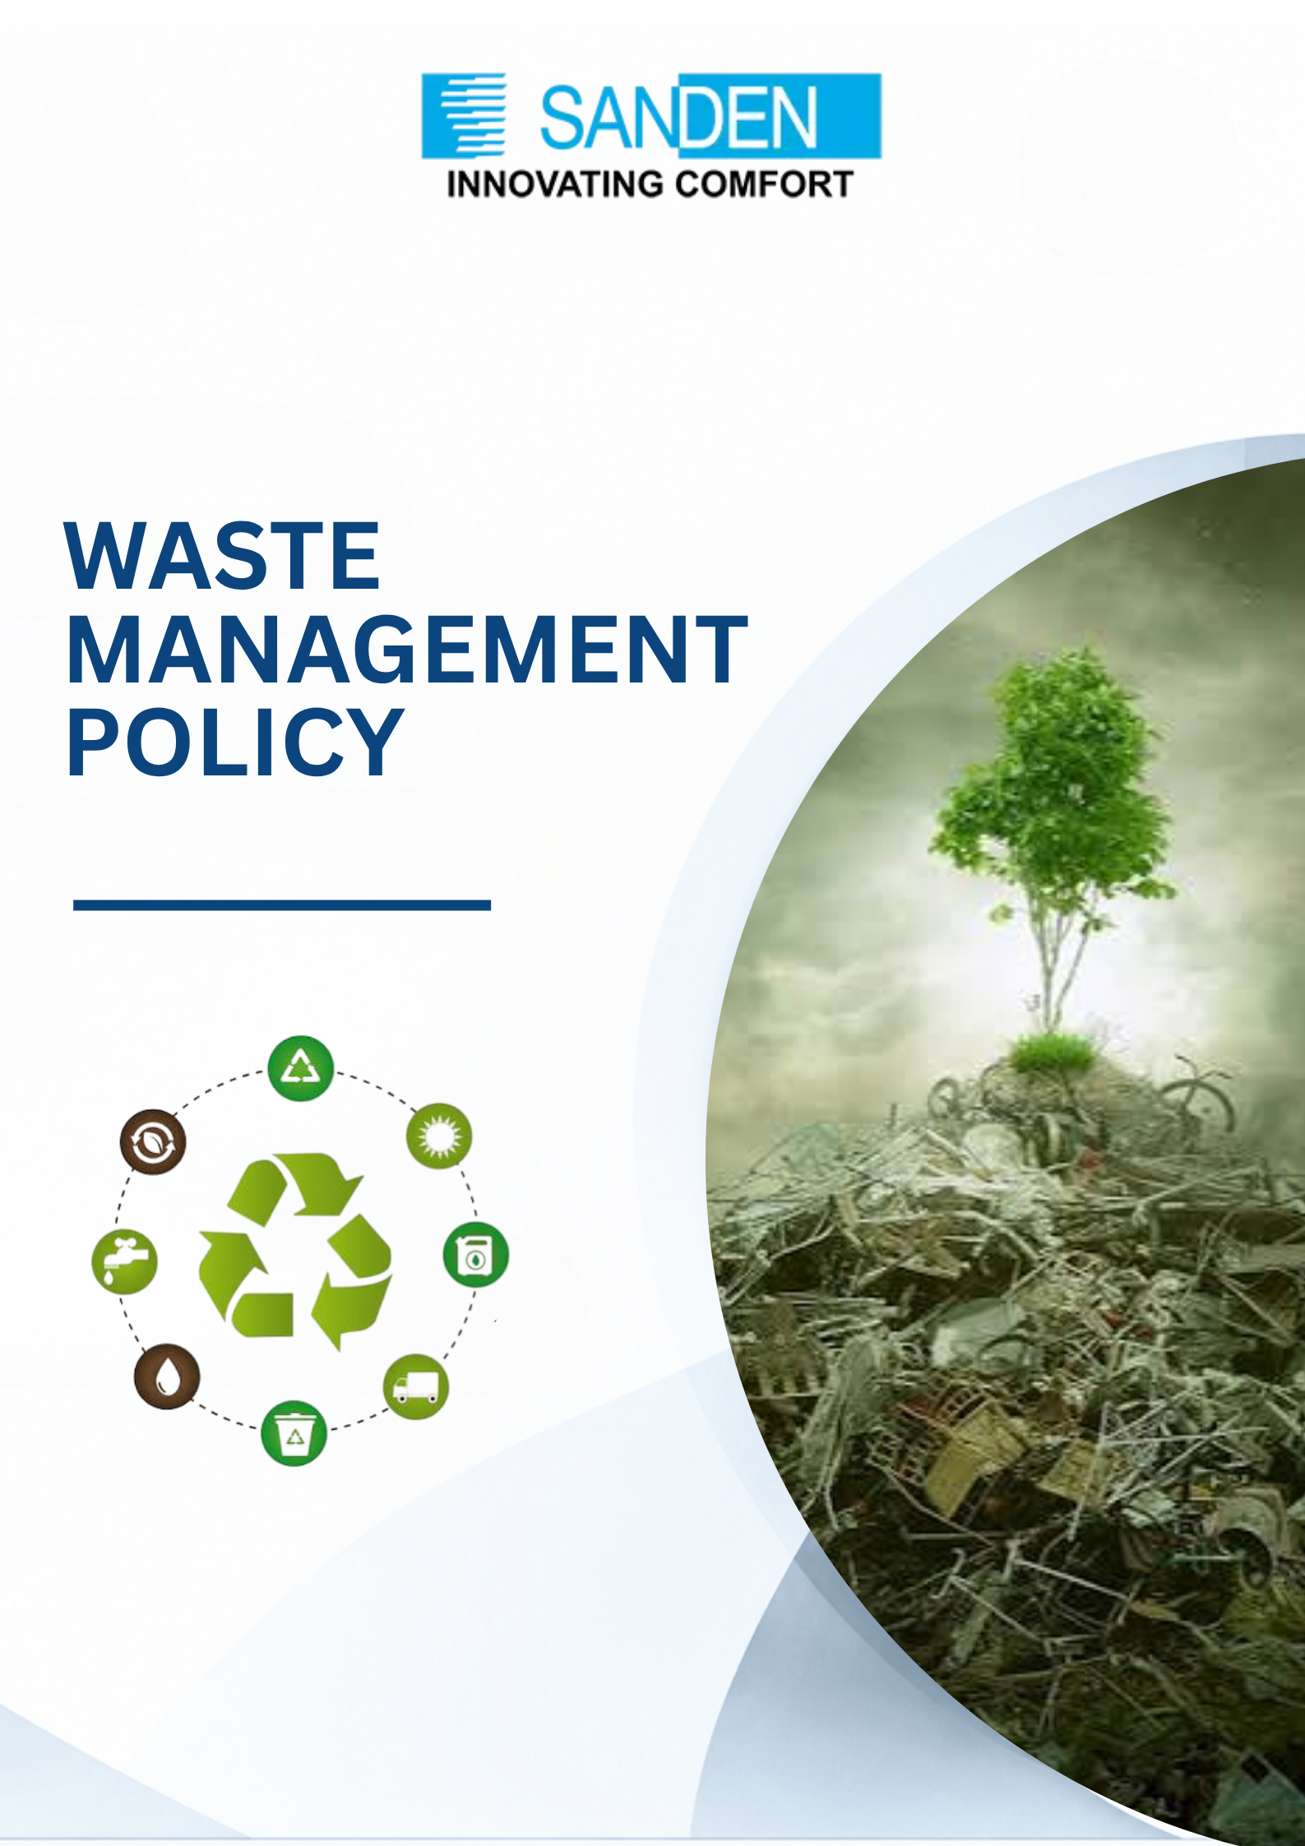

TABLE OF CONTENTS

S. No. | Topic
1 | PREFACE
2 | OBJECTIVE
3 | SCOPE
4 | WASTE MANAGEMENT APPROACH
5 | KEY COMMITMENT
6 | ROLES AND RESPONSIBLOITIES
7 | MONTIORING AND REVIEW
8 | POLICY REVIEW AND AMENDMENT

WASTE POLICY

1. PREFACE
Sanden Vikas (India) Private Limited recognizes that effective waste management is essential for environmental sustainability, regulatory compliance, and responsible business operations. The Group is committed to minimizing its environmental footprint by reducing waste generation, promoting resource efficiency, and adopting sustainable waste handling practices across its operations. This Policy supports the Group’s broader sustainability and ESG commitments while providing specific direction on waste management.

2. OBJECTIVE
The objective of this Policy is to:
- Establish a structured and consistent approach to waste management across the organization.
- Minimize environmental impact through reduction, reuse, recycling, and responsible disposal of waste.
- Promote resource efficiency and sustainable operational practices.
- Ensure compliance with applicable environmental laws and regulations.
- Support the Group’s ESG goals and sustainability commitments.

3. SCOPE
This Policy applies to all units, plants, offices, functions, employees, contractors, and business partners of Sanden Vikas involved in generation, handling, storage, transportation, and disposal of waste.
It has been framed in alignment with applicable environmental regulations, Pollution Control Board requirements, and recognized sustainability practices to ensure responsible and compliant waste management across the Group.

4. WASTE MANAGEMENT APPROACH
Sanden Vikas shall adopt a systematic and sustainable waste management approach based on the 3R principles i.e., Reduce, Reuse, and Recycle, which form the foundation of responsible waste management practices.
The Group shall prioritize:
- Reduction of waste at source through efficient use of materials and processes.
- Reuse of materials wherever feasible to extend lifecycle and reduce resource consumption.
- Recycling waste into usable materials to minimize environmental impact.
- Disposal shall be considered as the last resort after exploring all feasible alternatives.

5. KEY COMMITMENTS
Sanden Vikas is committed to:
- Implementing best practices in waste management aligned with sustainability and environmental protection.
- Striving to prevent pollution through structured waste management, air emission control, and prevention of soil degradation.

- Promoting waste segregation, safe handling, storage, and disposal practices.
- Reducing waste generation across operations through process optimization and efficiency improvements.
- Encouraging recycling and responsible disposal through authorized vendors and systems.
- Creating awareness and accountability among employees and stakeholders for responsible waste management.

ESG-Linked Targets
The Group shall pursue defined waste reduction targets from Base Year 2023-24, including:
- Reduction in non-hazardous waste by 50% by 2030
- Reduction in hazardous waste by 20% by 2030
- Zero waste to landfill by 2030

6. ROLES AND RESPONSIBILITIES

6.1 Management
- Provide direction and oversight for implementation of this Policy.
- Ensure availability of resources for waste management initiatives.
- Oversee integration of waste management performance into sustainability reporting.

6.2 Functional Heads
i. Ensure compliance with waste management practices within their functions.
ii. Identify opportunities for waste reduction and recycling.
iii. Report on performance metrics for inclusion in the Company’s Sustainability Report.

6.3 Employees
i. Follow established waste management practices and procedures.
ii. Segregate and handle waste responsibly.
iii. Report on any environmental risks or non-compliance.

7. MONITORING AND REVIEW
i. Waste generation, disposal, and recycling practices shall be periodically monitored.
ii. Performance shall be reviewed against defined ESG targets.
iii. Corrective actions should be initiated to address inefficiencies or non - compliance.
iv. Waste management performance shall be integrated into the Company’s annual Sustainability Report prepared under BRSR or equivalent frameworks.

8. POLICY REVIEW AND AMENDMENT
i. This Policy shall be reviewed periodically or as required due to changes in operations
or regulatory requirements.
ii. Management reserves the right to amend, modify, or update this Policy at its discretion.
iii. The document is the property of Sanden Vikas and is intended for limited internal circulation as per management discretion.

