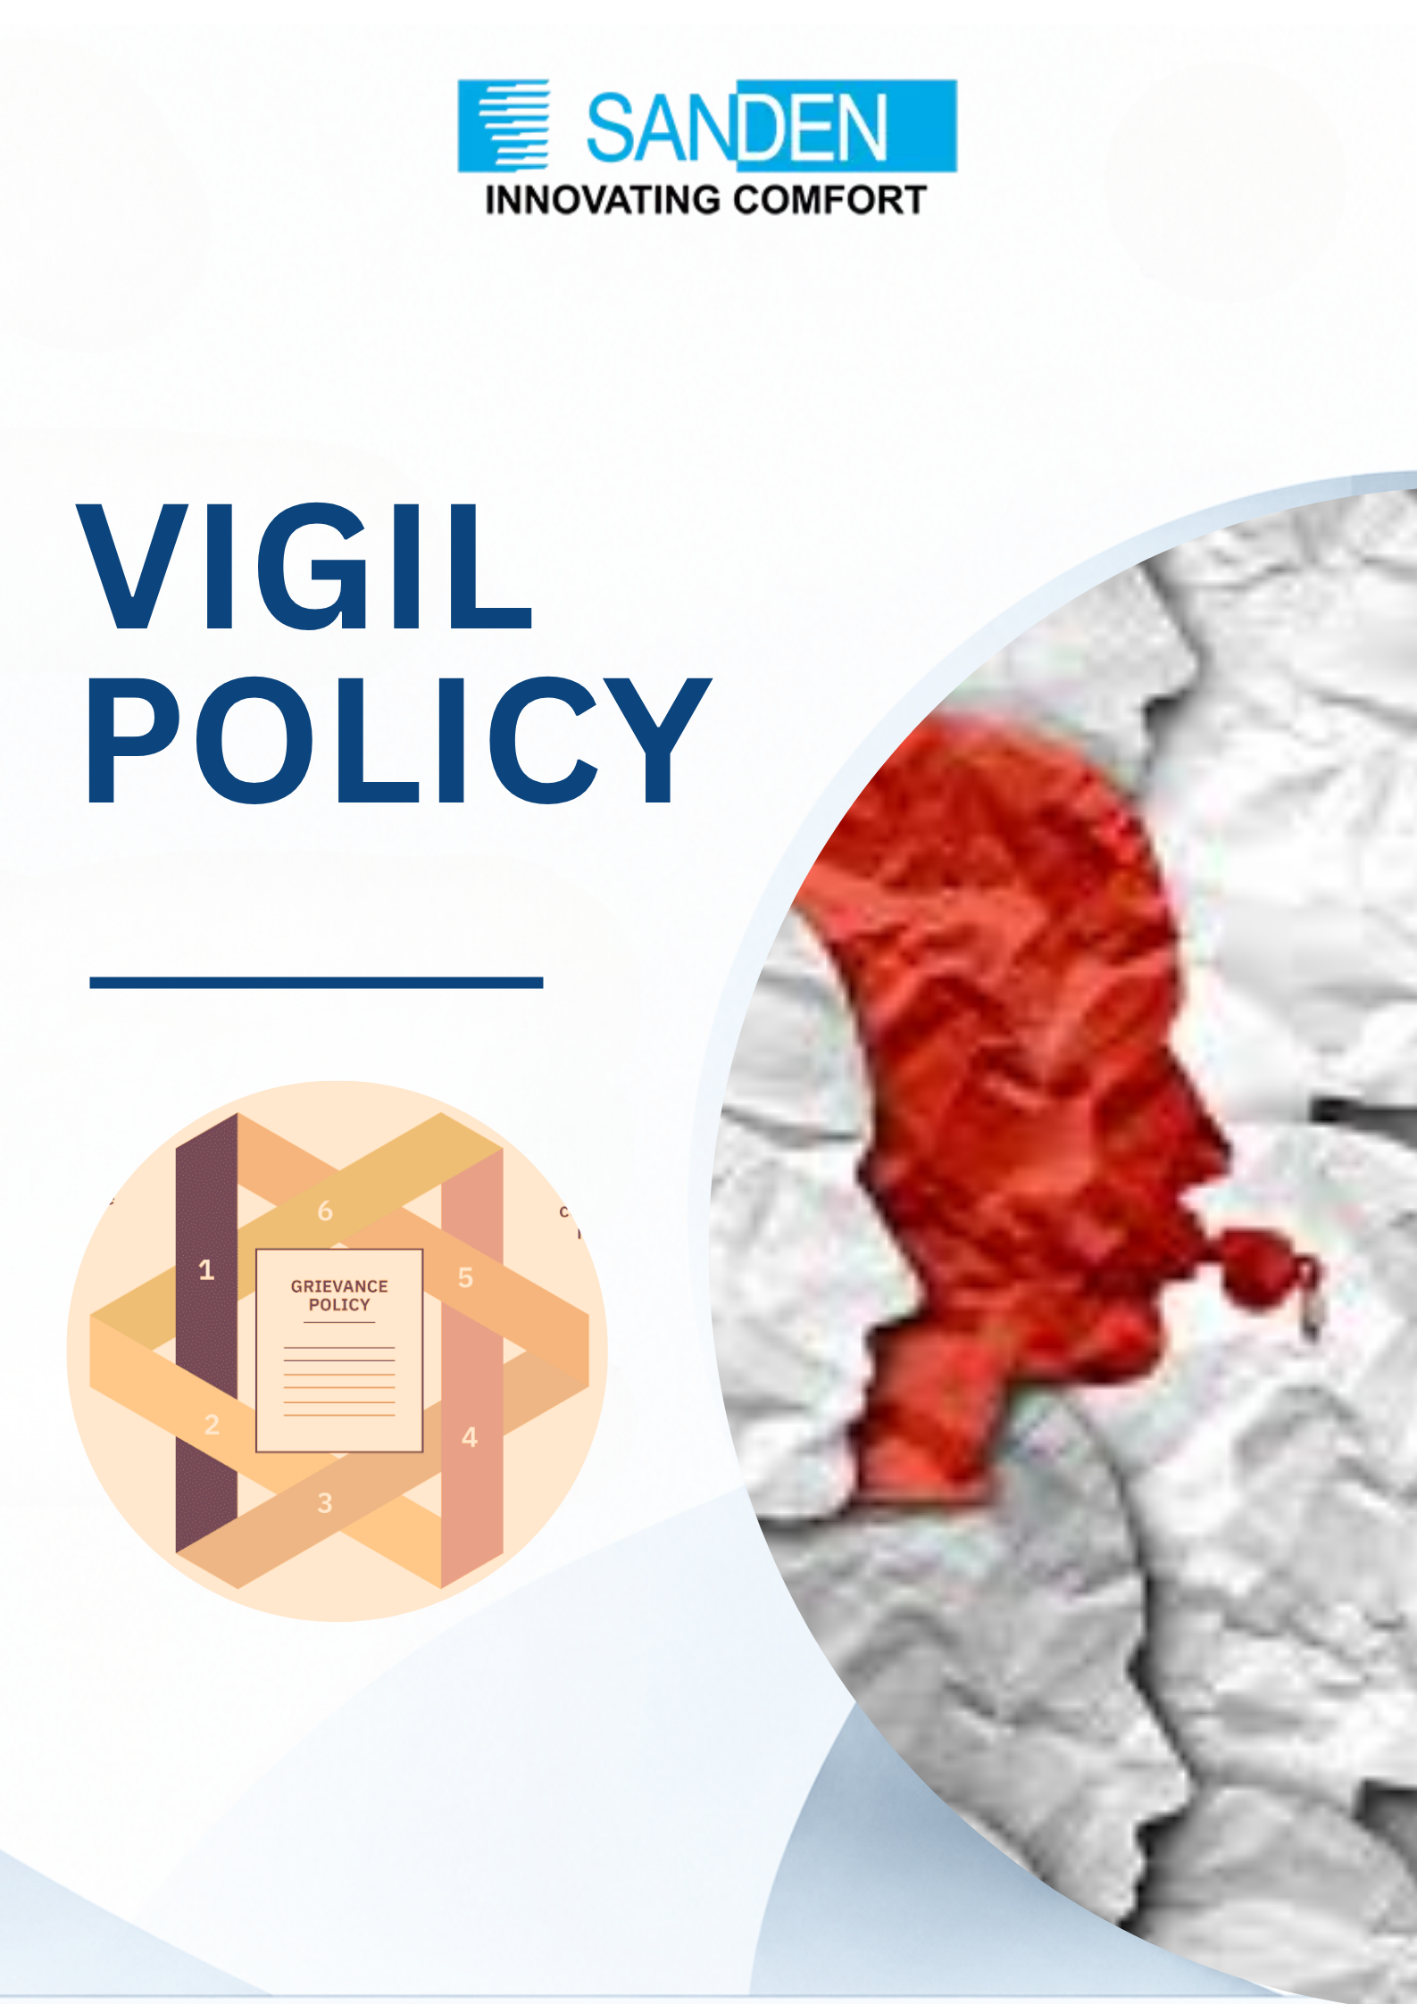

TABLE OF CONTENTS

S.No. | Topic
1 | PREFACE
2 | POLICY OBJECTIVE
3 | SCOPE
4 | DEFINITION
5 | EXCLUSION
6 | PROCEDURE
7 | PROCESS OWNER
8 | INVESTIGATION
9 | DECISION & REPORTING
10 | PROTECTION
11 | FRIVOLOUS, FICTITIOUS AND MALA FIED DISCLOSURE
12 | RETENTION OF DOCUMENTS
13 | COMPLIANCE
14 | COMMUNICATION & TRAINING
15 | ADMINISTRATION & REVIEW

VIGIL POLICY

PREFACE:
Sanden Vikas (India) Private Limited has adopted the Vigil Policy that aims to foster a culture of transparency, integrity, and accountability within the organization and to protect whistle-blowers from retaliation. This Policy outlines the procedures for reporting and addressing such concerns (related to malpractice, impropriety, abuse, or wrongdoing) in a confidential and transparent manner without fear of reprisal or victimization.

The policy aims to ensure that we are conducting business with responsibility & integrity. Our daily conduct reflects our core values and purpose which are integral to our brand and reputation.

CORE VALUES OF SANDEN VIKAS
Sanden Vikas has scripted a success story by following its Core Values of Truth, Honesty, Integrity; Respect and Discipline; Customer Delight; Collaboration, and Challenge and Innovation over the past four decades. These core values and business philosophy inform all our endeavors and constitute the foundation of our position as an industry leader in all our domains.

POLICY OBJECTIVES
- To maintain the standards of ethical, moral, and legal conduct of business.
- To provide a channel for the employees and individuals to report to the management any concerns about unethical behavior, actual or suspected fraud, or violation of policy.
- To provide adequate safeguards against victimization of whistle-blowers.
- To build & enforce the culture of strong governance, fairness, and transparency; to safeguard the Group against any adverse impact.

SCOPE
The Vigil Policy applies to all the employees associated with the Group companies of the Sanden Vikas. Disclosures can be made by Employees, Consultants, Third party employees, Workers/Associates, Trainees, Vendors, Service providers, Partners, JV employees, and Customers of Sanden Vikas.
It covers concerns related to unethical behavior, fraud, corruption, bribery, conflicts of interest, violations of laws or regulations, and any other wrongdoing, serious malpractice, or impropriety that may harm the interests of the company or its stakeholders.
This Vigil Policy is not intended to address individual employment-related grievances or disputes, such as salary negotiations, performance evaluations, transfers, or interpersonal conflicts. Employees are encouraged to utilize appropriate channels, such as HR or management, to address such concerns.

DEFINITIONS
The definitions of some of the key terms used in this Policy are given below.
- “Protected Disclosure” means a concern raised by an employee/individual or group of employees/individuals, through written communication and made in good faith which discloses or demonstrates information about an unethical or improper activity under the title “SCOPE OF THE POLICY” for the Company. It should be factual and not speculative or in an interpretation/conclusion and should contain as much specific information as possible to allow for proper assessment of nature and extent of the concern.

- “Subject” means a person or group of persons against or with whom a Protected Disclosure is made, or evidence gathered during an investigation.
- “Vigilance Officer” means an officer appointed to receive protected disclosures from whistle-blowers, maintaining records thereof, placing the same before the Audit Committee/MD for its disposal, and informing the whistle-blower of the result thereof.
- “Whistle-blower” is an employee or group of employees/individuals who makes a Protected Disclosure under this Policy and is also referred to in this policy as a complainant.
- “Complaint/Disclosure”: Malpractice, impropriety, abuse, and wrongdoing can include a whole variety of issues, and some are listed below. However, this is not a comprehensive list but is intended to illustrate the sort of issues, which may be raised under this Policy.
  - Any unlawful act, whether criminal (e.g. theft) or a breach of civil law (e.g. insult or defamation)
  - Breach of any Policy or Manual or Code of conduct adopted across Sanden Vikas.
  - Health and safety risks, including risks to the public as well as other employees (e.g. faulty electrical equipment)
  - Fraud and corruption (e.g. to solicit or receive any gift/reward as a bribe)
  - Any instance of failure to comply with legal or statutory obligation either for and on behalf of the Sanden Vikas or in any personal capacity in the course of discharging duties of the Sanden Vikas
  - Any instance of any sort of financial malpractice
  - Abuse of power (e.g. sullying/harassment/asking the team member to do personal work)
  - Any other unethical or improper conduct.
  - Use of company resources for personal use
  - Any undue favor or restraint based on caste, region, and gender.
  - Any act, omission, concealment of any fact or abuse of position committed by any person or any other person with the connivance in any manner, with intent to deceive, to gain undue advantage from, or to injure the interests of, the Sanden Vikas or its shareholders or its creditors, or any other person, whether there is any wrongful gain or wrongful loss.

EXCLUSIONS
Exclusions of a Vigil Policy at Sanden Vikas clarify what types of concerns are not covered:
- Personal Grievances- This whistleblower policy is not intended to address individual employment-related grievances or disputes, such as salary negotiations, performance evaluations, or interpersonal conflicts. Employees are encouraged to utilize appropriate channels, such as HR or management, to address such concerns.
- Anonymous Reports- Anonymous reports that do not provide sufficient information to initiate an investigation may not be actionable under this policy. While we encourage employees to report concerns anonymously if they feel uncomfortable disclosing their identity, providing detailed information is essential for effective investigation and resolution. This Policy encourages the whistle-blowers to mention their names while making the disclosure. Concerns expressed anonymously/pseudonymously will not be normally entertained. However, where an anonymous disclosure contains references to verifiable facts and figures, such cases will be taken up for investigation.
- Legal Advice- This whistle-blower policy is not a substitute for legal advice. Employees who require legal advice or assistance regarding their rights or obligations under the law should consult with legal counsel or appropriate authorities.
These exclusions help clarify the boundaries of the Vigil Policy and ensure that it is used appropriately to address issues affecting the organization's integrity, compliance, and ethical standards.

PROCEDURE
All Protected Disclosures should be reported as below:
    - Written Disclosure: The complainant as soon as possible, not later than 10 days after the whistle-blower becomes aware of the same and should either be typed or written in legible handwriting in English or Hindi. The Protected Disclosure should be submitted under a covering letter signed by the complainant in a closed and secured envelope and should be superscribed as “Protected disclosure under the Vigil Policy” or sent through email with the subject “Protected disclosure under the Vigil Policy”.
    - Oral Disclosures: If a whistle-blower desires to make an oral disclosure he/she may do so through telecon or by personally meeting the Vigilance Officer. If the disclosure is found to be valid, the said disclosure will be considered for an investigation as laid out in the procedure.
    - Disclosure through direct mail: If a whistle-blower desires to make a disclosure he/she may do so by sending an e-mail to the Vigilance Officer.
All Protected Disclosures should be addressed to the Vigilance Officer of the Sanden Vikas or to the MD in exceptional cases.

PROCESS OWNER
Designated Vigilance Officer of Sanden Vikas will be the process owner of this policy:

Name | Mr. Amit Gupta
Designation | AVP-Corporate Audit & Governance
Contact No.
Email ID | vigil.policy@vikasgroup.in

To protect the identity of the complainant, the Vigilance Officer will not issue any acknowledgment to the complainants, and they are not advised either to write their name/address on the envelope or enter any further correspondence with the Vigilance Officer. Anonymous disclosure shall not be entertained by the Vigilance Officer.
Also, to support the Vigilance Officer, a cross functional team including Corporate P&A and Corporate HR will be created.

Vigilance Officer will ensure that:
    - The received disclosure/concerns are preliminary investigated fairly and decisions are reported appropriately to all concerned, within the stipulated time limits.
    - The Vigil Policy is administered appropriately.
    - The oversees and provides perspective to investigations.
    - To work closely with HR and the chairperson of the audit committee/MD, to develop a progressive and positive employee work culture and high integrity.
    - The Vigilance Officer shall be nominated by the Audit Committee/MD.

INVESTIGATION
- All Protected Disclosures under this Policy will be recorded and thoroughly investigated.
- The Vigilance Officer will do a prima-facie review of the genuineness of the disclosure, within 7 days and if the disclosures are found to be frivolous or fictitious, or untrue of verifiable information, further action will not be initiated.
- The Vigilance Officer may investigate and may at its discretion consider involving any other officer of the Company and/or an outside agency for investigation.
- The decision to investigate is by itself not an accusation and is to be treated as a neutral fact-finding process.
- Subject(s) will normally be informed of the allegations at the outset of a formal investigation and have opportunities to provide their inputs during the investigation.

- Subject(s) have a right to consult with a person or persons of their choice, other than the Vigilance Officer / Investigators.
- The investigation should be completed normally within 30 days of the receipt of the Protected Disclosure and is extendable by such period as the Vigilance Officer deems fit.
- The Chairperson of the Audit Committee/MD based on review and analysis of facts will make the final decision which will be binding on all.
- The Vigilance Officer will send the final investigation report to the Director/COO/ED and Business HR or any person authorized by management within 7 days of completion of the report for necessary action.
- The Vigilance Officer will make quarterly/half-yearly/yearly presentations to the audit committee chairperson on the development, closure, and summary of the policy implementation.
- Appeal against the decision to the Audit Committee Chairperson/MD: If the whistle-blower/s or the subject is not satisfied with the decision then either of the parties could prefer an appeal against the decision to the Audit Committee Chairperson/MD, whose decision in the matter will be final and binding on all the parties.

DECISION AND REPORTING
- In the event it is proved that an improper or unethical act has been committed, the Vigilance Officer shall recommend to the management of the Company to take such disciplinary or corrective action as they may deem fit.
- The Vigilance Officer shall submit a report to the Vigilance Officer on a regular basis about all Protected Disclosures referred to him since the last report together with the results of investigations, if any.
- If the report of investigation is not to the satisfaction of the complainant, the complainant has the right to report the event to directly to the management.
- A complainant who makes false allegations of unethical & improper practices or about alleged wrongful conduct of the Subject to the Vigilance Officer shall be subject to appropriate disciplinary action in accordance with the rules, procedures and policies of the Company.

PROTECTION
- Complete protection will be given to whistle-blowers against any unfair practice like retaliation, threat or intimidation of termination/suspension of service, or disciplinary action including any direct or indirect use of authority to obstruct further Protected Disclosure.
- A whistle-blower may report any violation of the above clause to the Vigilance Officer, who shall recommend suitable action to the management after a proper investigation.
- The identity of the whistle-blower shall be kept confidential to the extent possible and permitted under law.

FRIVOLOUS, FICTITIOUS AND MALAFIED DISCLOSURE
If a whistle-blower alleges that she/he knows to be untrue or with an intent to defame and is confirmed by subsequent investigation, appropriate action will be taken against such whistle-blowers.
In case a habitual complainant is found to be making false/frivolous complaints, an appropriate disciplinary action will be initiated against the complainant. Further, the subsequent complaints/disclosures made by him may not be considered.

RETENTION OF DOCUMENTS
All Protected Disclosures in writing or documented along with the results of investigation relating thereto, shall be retained by the Company for 3 (three) years or such other period as specified by any other law in force, whichever is more.

COMPLIANCE
This Vigil Policy is intended to comply with all applicable laws and regulations governing whistle-blower protection and reporting obligations in India.

COMMUNICATION AND TRAINING
- Communication- Sanden Vikas will communicate this Vigil Policy to all employees and stakeholders and make it readily accessible through the company's intranet, employee handbook, or other appropriate channels.

- Training- Sanden Vikas will provide annual training to all the employees on the importance of whistle-blowing, their rights and responsibilities under this policy, and the reporting procedures.

ADMINISTRATION AND REVIEW OF THE POLICY:
The Nominated Vigilance Officer shall be responsible for the administration, interpretation, application, and review of this policy. He / She shall also be empowered to bring about necessary changes to this Policy, if required at any stage with the concurrence of the Board of Directors.

