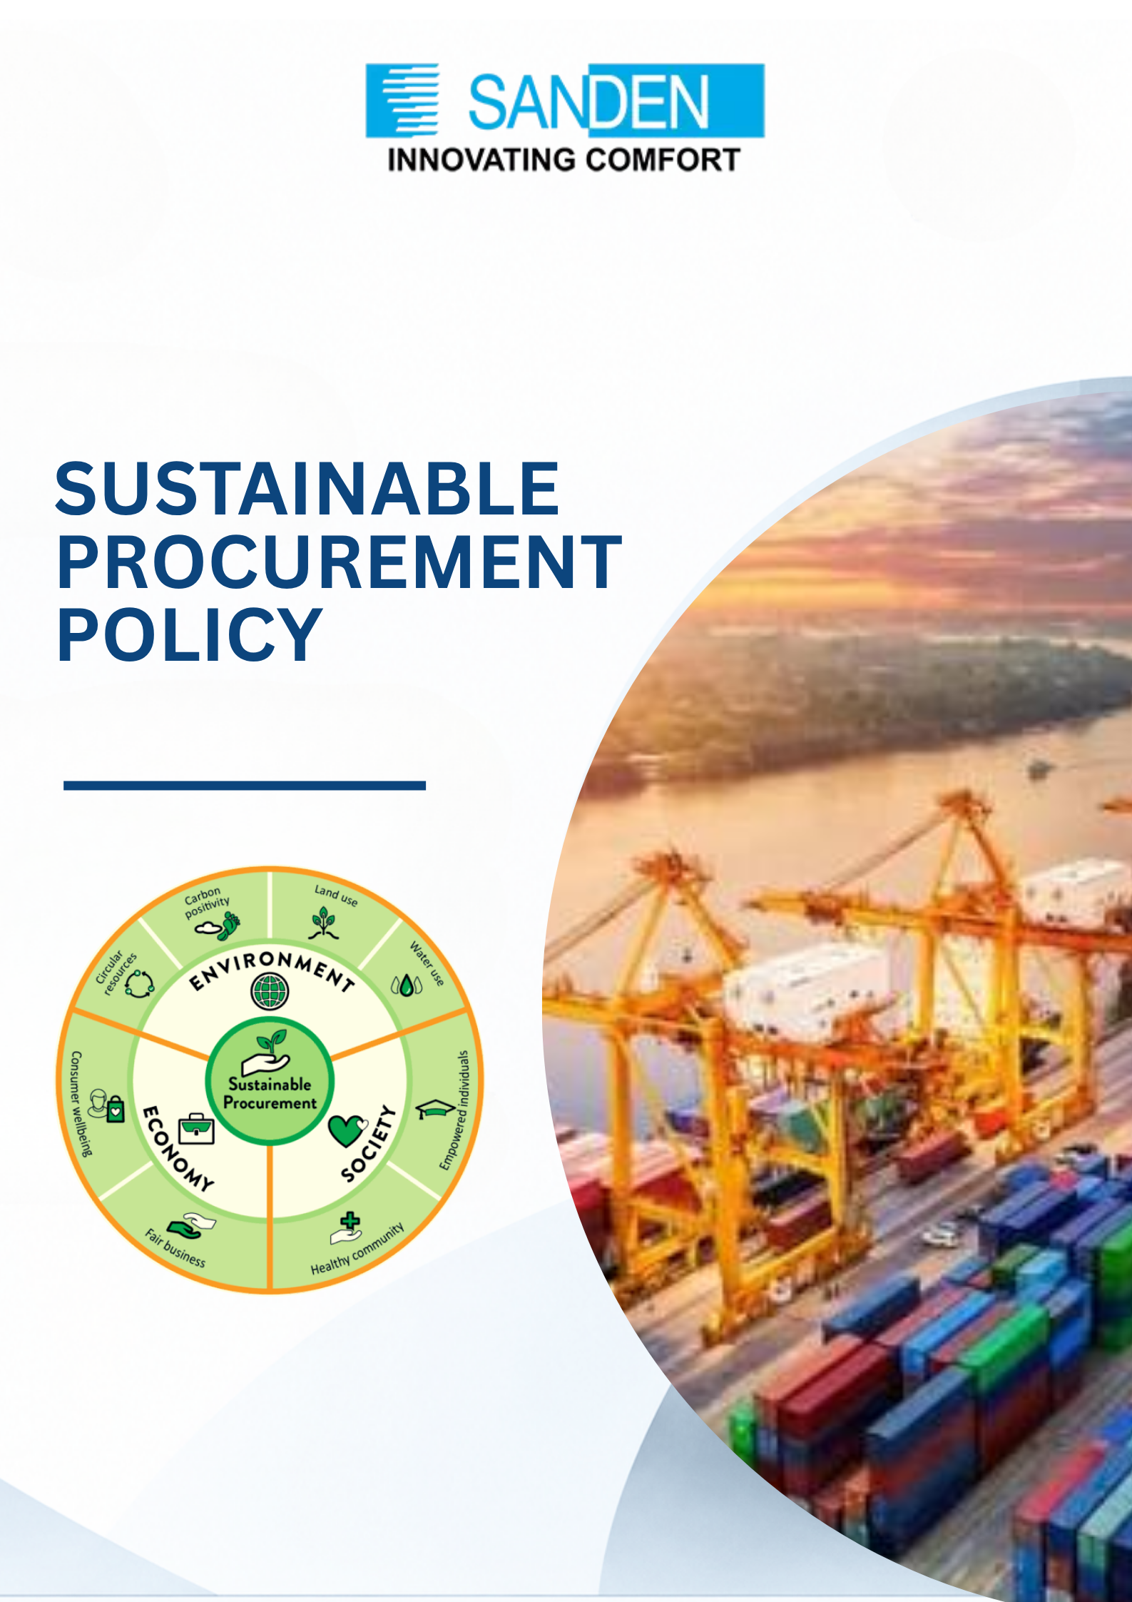

TABLE OF CONTENTS

S. No. | Topic
1 | PREFACE
2 | OBJECTIVE
3 | SCOPE AND APPLICABILITY
4 | PRINCIPLES
5 | SUPPLIER ENGAGEMENT
6 | SUSTAINABLE PROCUREMENT CRITERIA
7 | IMPLEMENTATION AND MONITORING
8 | REVIEW AND CONTINUOUS IMPROVEMENT
9 | APPROVAL AND RESPONSIBILITY

SUSTAINABLE PROCUREMENT policy

1. PREFACE
At Sanden Vikas (India) Private Limited, we recognize the importance of sustainable procurement in fostering environmental stewardship, social equity, and economic resilience. As a responsible organization, we are committed to making procurement decisions that align with our sustainability goals while maintaining transparency and accountability. This policy serves as a framework for ensuring that our purchasing practices contribute to a more sustainable future for all stakeholders.

2. OBJECTIVES:
- To establish guidelines for integrating sustainability into procurement practices to minimize environmental impact, support social responsibility, and ensure economic efficiency.
- To conduct awareness sessions to the value chain partners on Environment and Social Impacts.
- To educate the value chain partners to mitigate Environment and Social Impacts.
- To establish guidelines on conducting audits/ assessments of value chain partners on Environment and Social Impacts.
- To ensure that Supply Chain Management department gets suppliers’ declaration on REACH / CMRT especially for 3TG (Tin, Tungsten, Titanium, Gold).
- To promote business from Women- led enterprises or MSMEs.

3. SCOPE AND APPLICABILITY
- This policy applies to all procurement activities undertaken by Sanden Vikas or its subsidiary companies including purchasing goods, services, and works across all departments
- This policy addresses the company's responsibilities to understand and mitigate the Environment and Social Impacts of its operations through value chain.

4. PRINCIPLES

4.1 ENVIRONMENTAL RESPONSIBILITY
Prioritize products and services with minimal environmental impact, including energy-efficient, recyclable, and sustainably sourced materials.

4.2 SOCIAL RESPONSIBILITY
Support suppliers who uphold ethical labor practices, respect human rights, and promote diversity and inclusion throughout their operations.

4.3 ECONOMIC EFFICIENCY
Ensure procurement decisions balance cost-effectiveness with long-term sustainability benefits.

4.4 COMPLIANCE AND TRANSPARENCY
Adhere to all relevant regulations, industry standards, and ethical procurement practices.

5. SUPPLIER ENGAGEMENT
- Preference will be given to suppliers who actively demonstrate sustainable and responsible business practices.
- All suppliers are expected to comply with Environmental, Social, and Governance (ESG) criteria.
- We will offer training and capacity-building support to suppliers to enhance their understanding of environmental and social impact management.
- Suppliers will be encouraged to minimize waste generation, reduce carbon emissions, and optimize resource use.
- Suppliers are encouraged to submit their scope 1 & scope 2 data
- Periodic audits and assessments will be conducted to evaluate suppliers’ performance on environmental and social parameters.
- The company commits to engaging in fair trade and responsible sourcing initiatives across its supply chain.

6. SUSTAINABLE PROCUREMENT CRITERIA
- Products should be energy-efficient, non-toxic, recyclable, and designed for minimal environmental impact, wherever feasible.
- Services must integrate sustainable methodologies and demonstrate efforts to reduce their environmental footprint.
- Supplier evaluation will include assessment of their environmental and social performance.
- Suppliers must provide declarations regarding the presence of substances of concern and compliance with REACH, RoHS, and CMRT regulations.
- Preference will be given to locally sourced goods and services, wherever feasible, to reduce transport emissions and support local economies.

7. IMPLEMENTATION AND MONITORING
- Key sustainability performance indicators (KPIs) will be established and monitored across procurement activities.
- Supplier compliance with sustainability standards will be reviewed at least annually or upon changes in relevant environmental or social regulations.
- Procurement teams will receive regular training on sustainable procurement practices and updates on regulatory requirements.
- Progress on sustainability goals, supplier performance, and improvements will be documented and reported periodically.

8. REVIEW AND CONTINUOUS IMPROVEMENT
This policy will be reviewed on a regular basis to ensure continued relevance and alignment with emerging sustainability standards, industry best practices, and regulatory developments.

9. APPROVAL AND RESPONSIBILITY
Head of Department of Supply Chain Management of respective company of Sanden Vikas is responsible for overseeing the implementation of this policy and ensuring compliance across procurement activities.

