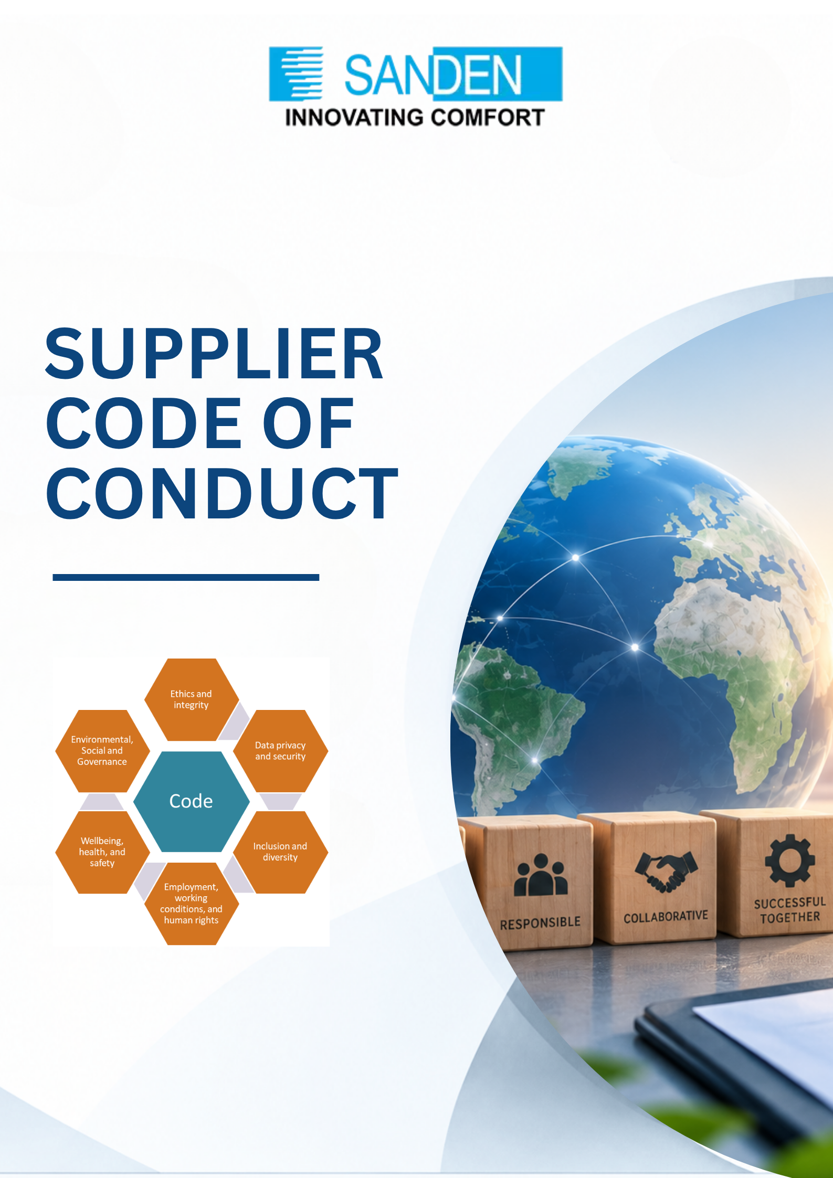

TABLE OF CONTENTS

S. No. | Topic
1 | INTRODUCTION AND PURPOSE
2 | SCOPE AND APPLICABILITY
3 | ETHICAL BUSINESS CONDUCT
4 | HUMAN RIGHTS AND LABOUR PRACTICIES
5 | HEALTH AND SAFETY
6 | ENVIRONMENTAL RESPONSIBILITY
7 | PRODUCT, MATERIAL AND REGULATORY COMPLIANCE
8 | DATA PRIVACY AND INFORMATION SECURITY
9 | AUDITING, ASSESSMENTS AND TRANSPARENCY
10 | CORRECTIVE ACTION AND CONTINOUS IMPROVEMENT
11 | REPORTING CONCERNS AND NON-RETALIATION
12 | CONSEQUENCES OF NON-COMPLIANCE
13 | IMPLEMENTATION AND MONITORING
14 | SUPPLIER DECLARATION AND COMMITMENT

SUPPLIER CODE OF CONDUCT

1. INTRODUCTION AND PURPOSE
Sanden Vikas (India) Private Limited is committed to conducting business responsibly, ethically and sustainably and expects the same commitment from its suppliers, contractors, subcontractors, service providers and other business partners.
This Supplier Code of Conduct (“Code”) establishes the minimum standards and expectations that suppliers must meet as a condition of doing business with Sanden Vikas.
Suppliers are expected to comply with this Code in both letter and spirit, applicable laws and regulations, and the contractual requirements agreed with Sanden Vikas.

2. SCOPE AND APPLICABILITY
This Code applies to all suppliers, contractors, subcontractors, service providers and other business partners providing products or services to Sanden Vikas.
Suppliers are responsible for communicating the principles and requirements of this Code to their employees, agents, contractors and relevant sub-suppliers and for taking reasonable steps to ensure compliance throughout their supply chain.
The requirements of this Code are in addition to, and do not replace, applicable laws, regulations, contractual obligations or customer requirements.
Suppliers shall maintain appropriate records and evidence demonstrating compliance with the requirements of this Code.

3. ETHICAL BUSINESS CONDUCT

3.1 Anti-Bribery and Anti-Corruption
Suppliers shall conduct business with integrity and shall comply with all applicable anti-bribery and anti-corruption laws.
Suppliers shall not offer, promise, authorize, provide or accept any bribe, kickback, facilitation payment or other improper advantage, directly or indirectly, to influence a business decision.
Suppliers shall maintain appropriate controls to prevent, detect and report corruption and unethical conduct.

3.2 Conflict of Interest
Suppliers shall avoid situations that create, or appear to create, a conflict between personal interests and business interests.
Any actual or potential conflict of interest involving Sanden Vikas employees or representatives shall be disclosed promptly.

3.3 Gifts and Hospitality
Gifts, entertainment, hospitality or other benefits offered to Sanden Vikas employees shall be reasonable, legitimate, infrequent and consistent with applicable laws and Sanden’s requirements.
No gift or hospitality shall be offered with the intention of improperly influencing a business decision.

3.4 Fair Competition
Suppliers shall compete fairly and comply with applicable competition and antitrust laws.
Suppliers shall not engage in price fixing, bid rigging, market allocation, abuse of dominant position or other anti-competitive practices.

3.5 Anti-Money Laundering
Suppliers shall comply with applicable laws relating to prevention of money laundering, terrorist financing and other financial crimes.

3.6 Confidentiality and Intellectual Property
Suppliers shall protect Sanden Vikas's confidential information, intellectual property, technical information, drawings, specifications, designs and other proprietary information.
Such information shall only be used for authorized business purposes.

4. HUMAN RIGHTS AND LABOUR PRACTICES
Sanden Vikas respects internationally recognized human rights and expects suppliers to respect the dignity, rights and well-being of all workers.
Suppliers shall provide a workplace free from forced labour, child labour, discrimination, harassment and abuse.
Suppliers shall comply with applicable laws concerning Minimum wages; Overtime; Working hours; Leave; Social security and statutory benefits; etc.
Suppliers shall provide workers with accessible mechanisms to raise concerns or grievances without fear of retaliation and shall investigate legitimate complaints promptly and take appropriate corrective action.

5. HEALTH AND SAFETY
Suppliers shall provide a safe and healthy workplace and shall take proactive measures to prevent occupational injuries, illnesses and fatalities.
Suppliers shall comply with applicable occupational health and safety laws and maintain appropriate policies, procedures, risk assessments, training, emergency preparedness and personal protective equipment requirements.

6. ENVIRONMENTAL RESPONSIBILITY
Suppliers shall comply with applicable environmental laws, permits, consents and regulatory requirements and shall seek to minimise the environmental impact of their operations.
The existing code requires suppliers to minimise impacts associated with resource consumption, emissions and waste and to monitor environmental performance where feasible.
Suppliers shall progressively improve environmental performance through appropriate controls, monitoring and resource-efficiency measures such as energy efficiency, water management, waste management, etc.
Suppliers shall seek to avoid or minimise adverse impacts on biodiversity and ecosystems arising from their operations.

Where operations are located in or near environmentally sensitive areas, appropriate environmental risk assessments and mitigation measures shall be implemented.
Environmental incidents, including significant spills, releases, regulatory violations or other events that may materially affect the environment or Sanden Vikas, shall be reported promptly and appropriate corrective action shall be taken.

7. PRODUCT, MATERIAL AND REGULATORY COMPLIANCE
Suppliers shall ensure that products and services supplied to Sanden Vikas comply with applicable laws, regulations, customer requirements and agreed specifications.
The existing Code specifically addresses product quality, packaging and labelling, REACH, RoHS, material compliance and Substances of Concern.
Suppliers shall, where applicable:
- Comply with applicable product safety requirements;
- Maintain required technical documentation;
- Provide accurate material declarations;
- Comply with restricted-substance requirements;
- Provide information relating to Substances of Concern;
- Maintain appropriate traceability;
- Support applicable Extended Producer Responsibility requirements;
- Provide recycled-content information where contractually or legally required;
- Comply with applicable battery, e-waste and other product-related regulations; and
- Provide information required for customer sustainability and regulatory reporting.

Where relevant to the product or industry, suppliers should maintain appropriate systems such as material declaration and responsible-sourcing systems.

8. DATA PRIVACY AND INFORMATION SECURITY
Suppliers shall protect confidential information and personal data received from or relating to Sanden Vikas, its employees, customers and business partners.
The existing code requires suppliers to comply with applicable data privacy and information-security requirements and any material information-security or data breach affecting Sanden Vikas shall be reported promptly.

9. AUDITING, ASSESSMENTS AND TRANSPARENCY
Sanden Vikas may assess supplier compliance with this Code through:
- Self-assessments;
- Documentation reviews;
- Questionnaires;
- Physical audits;
- Virtual audits;
- Hybrid audits; and/or
- Independent third-party assessments

Suppliers shall provide reasonable access to relevant Personnel; Facilities; Records; Policies and procedures; Licences and statutory approvals; and other evidence necessary to assess compliance.

10. CORRECTIVE ACTION AND CONTINUOUS IMPROVEMENT
Where non-compliance is identified, the supplier shall develop and implement a Corrective Action Plan (CAP) within the agreed timeframe.
Critical issues involving potential fatalities, serious human-rights violations, child or forced labour, major environmental damage, corruption or significant legal violations may require immediate action.

11. REPORTING CONCERNS AND NON-RETALIATION
Suppliers, their employees and relevant stakeholders are encouraged to report suspected violations of this Code at vigil@vikasgroup.in

12. CONSEQUENCES OF NON-COMPLIANCE
Failure to comply with this Code may result in appropriate action depending on the nature, severity and recurrence of the violation.
Actions may include:
- Increased monitoring;
- Improvement plans;
- Suspension or termination of specific orders;
- Legal proceedings
Critical violations may result in immediate escalation and action.

13. IMPLEMENTATION AND MONITORING
Sanden Vikas may periodically review and update this Code to reflect changes in:
- Applicable laws and regulations;
- Customer expectations;
- ESG and sustainability standards;
- Industry practices;
- Environmental and climate risks; and
- Human-rights and responsible-business expectations.
Suppliers are expected to support continuous improvement and cooperate with Sanden Vikas in implementing revised requirements.

19. SUPPLIER DECLARATION AND COMMITMENT
By accepting this Code, the supplier confirms that it has:
- Received and understood the Sanden Vikas Supplier Code of Conduct;
- Communicated applicable requirements to relevant employees and business partners;
- Committed to comply with the Code in both letter and spirit;
- Committed to comply with all applicable laws and regulations;
- Agreed to provide reasonable information and cooperation for assessments and audits;
- Accepted responsibility for appropriate compliance by its employees, agents, contractors and relevant sub-suppliers; and
- Understood that non-compliance may result in corrective action, suspension, termination of business and/or other appropriate action.

This Code forms an integral part of the supplier relationship and shall be read together with applicable contracts, purchase orders, specifications and other Sanden Vikas requirements.
SUPPLIER ACKNOWLEDGEMENT
Supplier Name: _______________________________
Address: _____________________________________
Authorized Representative: _____________________
Designation: __________________________________
Signature: ____________________________________
Date: ________________________________________
Company Stamp: _______________________________

This version is intentionally structured so that the Code remains a policy-level document, while detailed requirements such as HIRA methodology, LOTO procedure, contractor safety, environmental data templates and ESG supplier scoring can sit in separate SOPs/standards. That will make it much easier to implement across the Sanden Vikas supplier base rather than making the Code unnecessarily operational.

