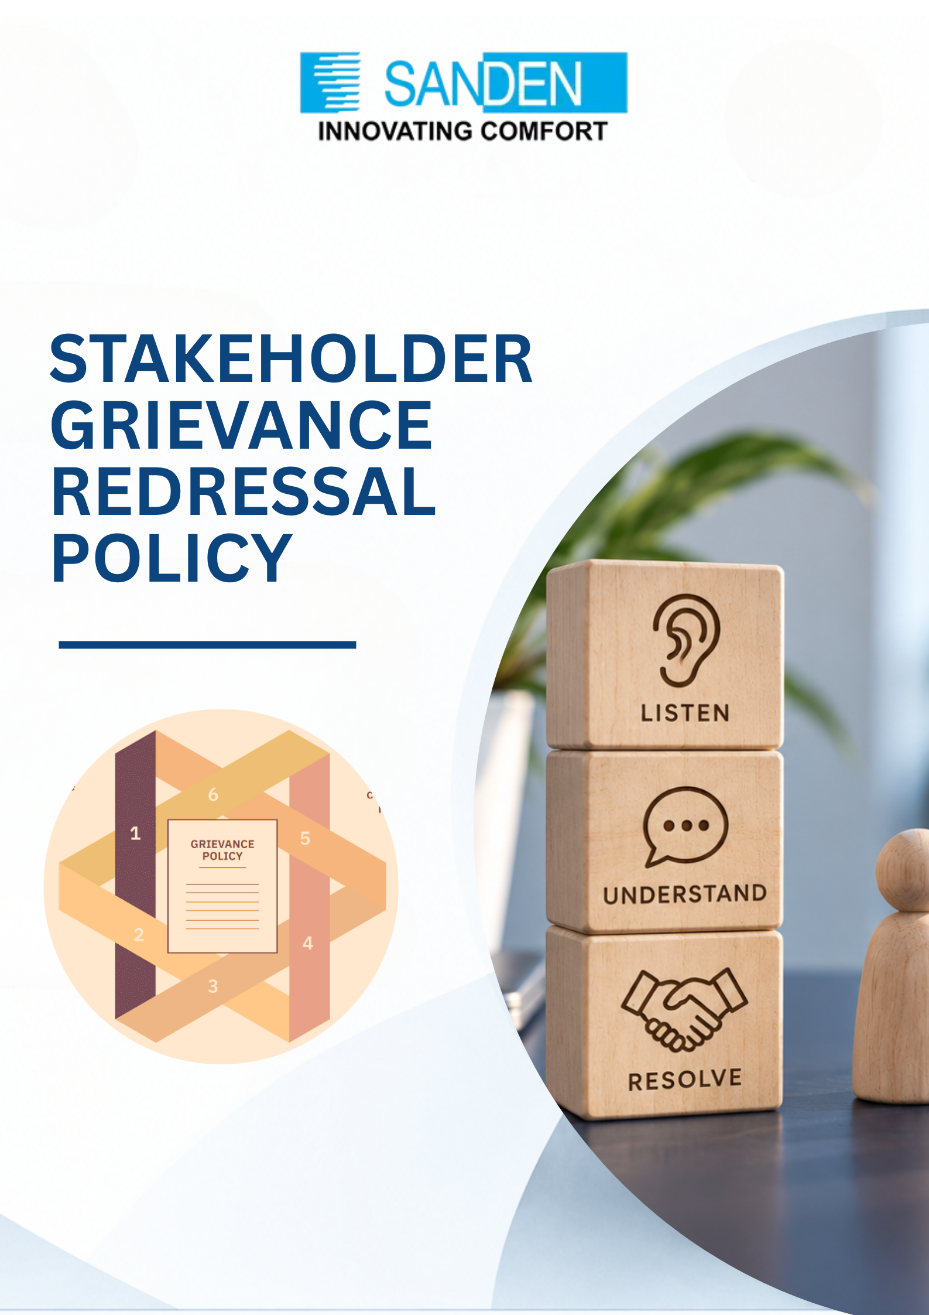

TABLE OF CONTENTS

S. No. | Topic
1 | PREFACE
2 | OBJECTIVE
3 | SCOPE
4 | GRIEVANCE CATEGORIES
5 | DEFINITIONS
6 | GRIEVANCE CHANNELS
7 | GUIDING PRINCIPLES
8 | GRIEVANCE HANDLING PROCEDURE
9 | ESCALATION MATRIX
10 | RECORD KEEPING AND DATA MANAGEMENT
11 | TRAINING AND AWARENESS
12 | MONITORING, REPORTING AND REVIEW
13 | NON-RETALIATION
14 | RESPONSIBILITIES
15 | ANNEXURE I – GRIEVANCE RECORD
16 | POLICY APPROVAL

STAKEHOLDER GRIEVANCE REDRESSAL POLICY

1. PREFACE
Sanden Vikas (India) Private Limited is committed to conducting its business in an ethical, transparent, responsible and sustainable manner. The organization recognizes that its operations, products, services, sites, supply chain and stakeholder relationships may affect external stakeholders, including customers, suppliers, contractors, service providers, business partners, local communities, visitors, regulators, investors/shareholders and other third parties.
This Policy establishes an accessible, fair, predictable, transparent and confidential mechanism through which external stakeholders can raise concerns, complaints, grievances, feedback or requests for clarification and seek appropriate and timely redressal without fear of retaliation.

2. OBJECTIVES
Provide clear and accessible channels for external stakeholders to raise grievances.
- Ensure grievances are acknowledged, assessed, investigated and addressed in a fair, impartial and timely manner.
- Protect complainants from retaliation, discrimination, intimidation or adverse action for raising concerns in good faith.
- Provide appropriate escalation where grievance is unresolved, significant, sensitive or involves a conflict of interest.
- Identify recurring issues, root causes and opportunities for corrective and preventive action.
- Support the organization’s commitments relating to ESG, responsible business conduct, human rights, stakeholder engagement and regulatory compliance.

3. SCOPE
This Policy applies to grievances connected with organization business activities, products, services, projects, facilities/sites, contractors, suppliers, community interactions, environmental and social impacts, contractual or service-related matters, ethical conduct, health and safety, human rights, customer service and other matters within the organization’s reasonable control or influence.
External stakeholders may include:
- Customers
- Suppliers and contractors
- Service providers and business partners
- Local communities and community representatives
- Visitors
- Regulators and government authorities
- Investors/shareholders, where applicable
- Other relevant third parties
This Policy does not replace statutory, judicial, regulatory, contractual, employment-related or law-enforcement remedies. Matters governed by specific statutory or internal mechanisms may be redirected to the appropriate mechanism.

4. GRIEVANCE CATEGORIES
- Human rights and responsible business conduct
- Environmental impacts, pollution, waste, water, biodiversity or community environmental concerns
- Health and safety concerns affecting stakeholders or communities
- Labour, working-condition or contractor-related concerns wherever relevant to external stakeholders
- Discrimination, harassment or other prohibited conduct, subject to applicable dedicated mechanisms
- Supplier, contractor or business partner conduct
- Product, service or customer-related concerns
- Ethical, integrity, fraud, bribery or conflict-of-interest concerns, subject to applicable whistle-blower/ethics mechanisms
- Community engagement, land/site-related or other stakeholder-impact concerns
- Other concerns connected with organization operations or business relationships

Complaints related to daily operations management such as quality defects, nominal
payment variations, etc., will not be considered as a Grievance.

5. DEFINITIONS
Term | Definition
Complainant | An external stakeholder who raises a grievance, either directly or on behalf of an affected group or organization.
Respondent | The individual, function, contractor, supplier, service provider, business partner or other party whose action, omission or conduct is the subject of the grievance.
External Stakeholder | An individual, group or organization outside Sanden Vikas that interacts with, is affected by, or has an interest in the organization’s operations, products, services, sites, supply chain or business activities.
SPOC | A designated Single Point of Contact responsible for receiving, acknowledging, coordinating, communicating and facilitating grievance resolution.
Grievance Handling Mechanism | The process for receiving, acknowledging, assessing, investigating, resolving, escalating, recording and reviewing grievances.
Retaliation | Any adverse action, intimidation, threat, discrimination, harassment, unfair treatment or disadvantage imposed for raising a grievance in good faith or participating in its review.
Good Faith | Raising a concern honestly and with a reasonable belief that the information provided is true, even if the concern is ultimately not substantiated.
Resolution | The action, decision, corrective measure, clarification, response or closure outcome communicated following review or investigation.

6. GRIEVANCE CHANNELS
External stakeholders may raise grievances through the designated SPOC, relevant function/site representative, email, letter, telephone, meeting or other approved channels communicated by the organization.
The current designated grievance contact details shall be published on the organization’s website and relevant stakeholder-facing communications. Only monitored and operational contact details should be published.
Where a grievance is received through another channel, it shall be forwarded to the appropriate SPOC/function for registration and handling.

7. GUIDING PRINCIPLES
Principle | Commitment
Accessibility | Stakeholders should have reasonable access to grievance channels without unnecessary barriers.
Confidentiality | Information shall be handled with due confidentiality and shared only with people who have a legitimate need to know, subject to applicable law.
Fairness and Impartiality | Grievances shall be reviewed objectively and relevant parties given an appropriate opportunity to provide information.
Timeliness | Grievances shall be acknowledged and addressed within defined target timelines, considering their nature and complexity.
Non-Retaliation | Sanden Vikas shall not tolerate retaliation, intimidation, discrimination or adverse action against a stakeholder, raising grievance in good faith.
Conflict of Interest | Anyone with an actual or potential conflict of interest shall disclose it and, wherever practicable, recuse themselves from the review.
Transparency | Stakeholders shall receive appropriate information on the status and outcome, subject to confidentiality and legal constraints.
Continuous Improvement | Grievance trends should be analyzed to identify systemic issues and corrective/preventive actions.

8. GRIEVANCE HANDLING PROCEDURE

8.1 Receipt and Registration
Each grievance shall be recorded with sufficient information to enable assessment and follow-up. Anonymous grievances may be considered where adequate information is available for investigation.

8.2 Acknowledgement
The concerned function/SPOC shall acknowledge receipt within 5 working days, wherever contact details are available.

8.3 Initial Assessment
The SPOC/function shall assess nature, urgency, severity, potential impact and appropriate owner of grievance. Matters falling under another dedicated mechanism shall be referred appropriately, with due confidentiality.

8.4 Investigation
Where required, grievance shall be investigated by gathering relevant information and evidence, consulting appropriate functions and reviewing applicable policies, contractual requirements and laws.

8.5 Resolution
The function concerned should seek a fair and appropriate resolution and communicate the outcome in writing wherever contact details are available. The target for ordinary formal grievances is 15 working days, subject to complexity.

8.6 Escalation and Appeal
If unresolved, significant, sensitive or beyond the authority of the function concerned, the matter may be escalated to the relevant Function/Business Head and thereafter to the designated Grievance Redressal Committee (GRC) or senior management.
Where a complainant is dissatisfied with the decision, an escalation may ordinarily be requested within 7 working days of communication of the decision. The GRC shall review the matter and communicate its decision within a target of 20 working days, wherever practicable.

GRC would be comprised of: Facility Head, HR Head, Admin Head

8.7 Closure
A grievance shall be closed when an appropriate response/resolution has been communicated, required corrective actions have been initiated or completed as applicable, and the case is appropriately documented. Closure shall not prevent a stakeholder from exercising statutory or other lawful remedies.

9. ESCALATION MATRIX
Level | Responsible Authority | Typical Responsibility
Level 1 | SPOC / Concerned Function | Receipt, registration, initial assessment and resolution
Level 2 | Function/Business Head | Review of unresolved or escalated grievances
Level 3 | Grievance Redressal Committee (GRC) | Independent/management review of escalated or sensitive matters
Level 4 | COO / Executive Director / Managing Director, as applicable | Final internal review of significant or unresolved matters

10. RECORD KEEPING AND DATA MANAGEMENT
All grievances and related documentation, including submissions, investigation records, decisions, communications and corrective actions, shall be securely maintained by the responsible function.
Records should be retained for a minimum of three years from closure, unless a longer period is required by applicable law, contractual requirements, litigation hold or company record-retention requirements. Access shall be restricted to authorized personnel.

11. TRAINING AND AWARENESS
Relevant employees and functions responsible for stakeholder engagement shall be made aware of this Policy and their responsibilities. Information on available grievance channels shall be communicated to relevant external stakeholders through the website, stakeholder engagement, contractual communications and other appropriate channels.

12. MONITORING, REPORTING AND REVIEW
The effectiveness of the grievance mechanism should be monitored periodically. SVL shall review grievance volumes, categories, response times, unresolved matters, recurring issues and corrective actions, while protecting confidentiality.
Material or significant trends may be reported to senior management and incorporated, where appropriate, into ESG/BRSR governance and stakeholder-engagement processes. This Policy should be reviewed at least annually or earlier where required due to legal, organizational, stakeholder or operational changes.

13. NON-RETALIATION
Sanden Vikas shall not tolerate retaliation, discrimination, intimidation, harassment or adverse action against an external stakeholder for raising grievance or concern in good faith or participating in the grievance process.

14. RESPONSIBILITIES
Role | Key Responsibilities
SPOC / Concerned Function | Receive, register, acknowledge, assess, coordinate investigation, communicate and maintain records.
Function/Business Head | Ensure timely and appropriate resolution and escalation where required.
GRC | Review escalated, significant, sensitive or unresolved grievances and recommend/decide appropriate action within its authority.
Senior Management | Provide oversight for significant or unresolved matters and ensure appropriate resources and corrective actions.
ESG/Sustainability / HR, as designated | Monitor trends and support policy implementation, reporting and periodic review.

