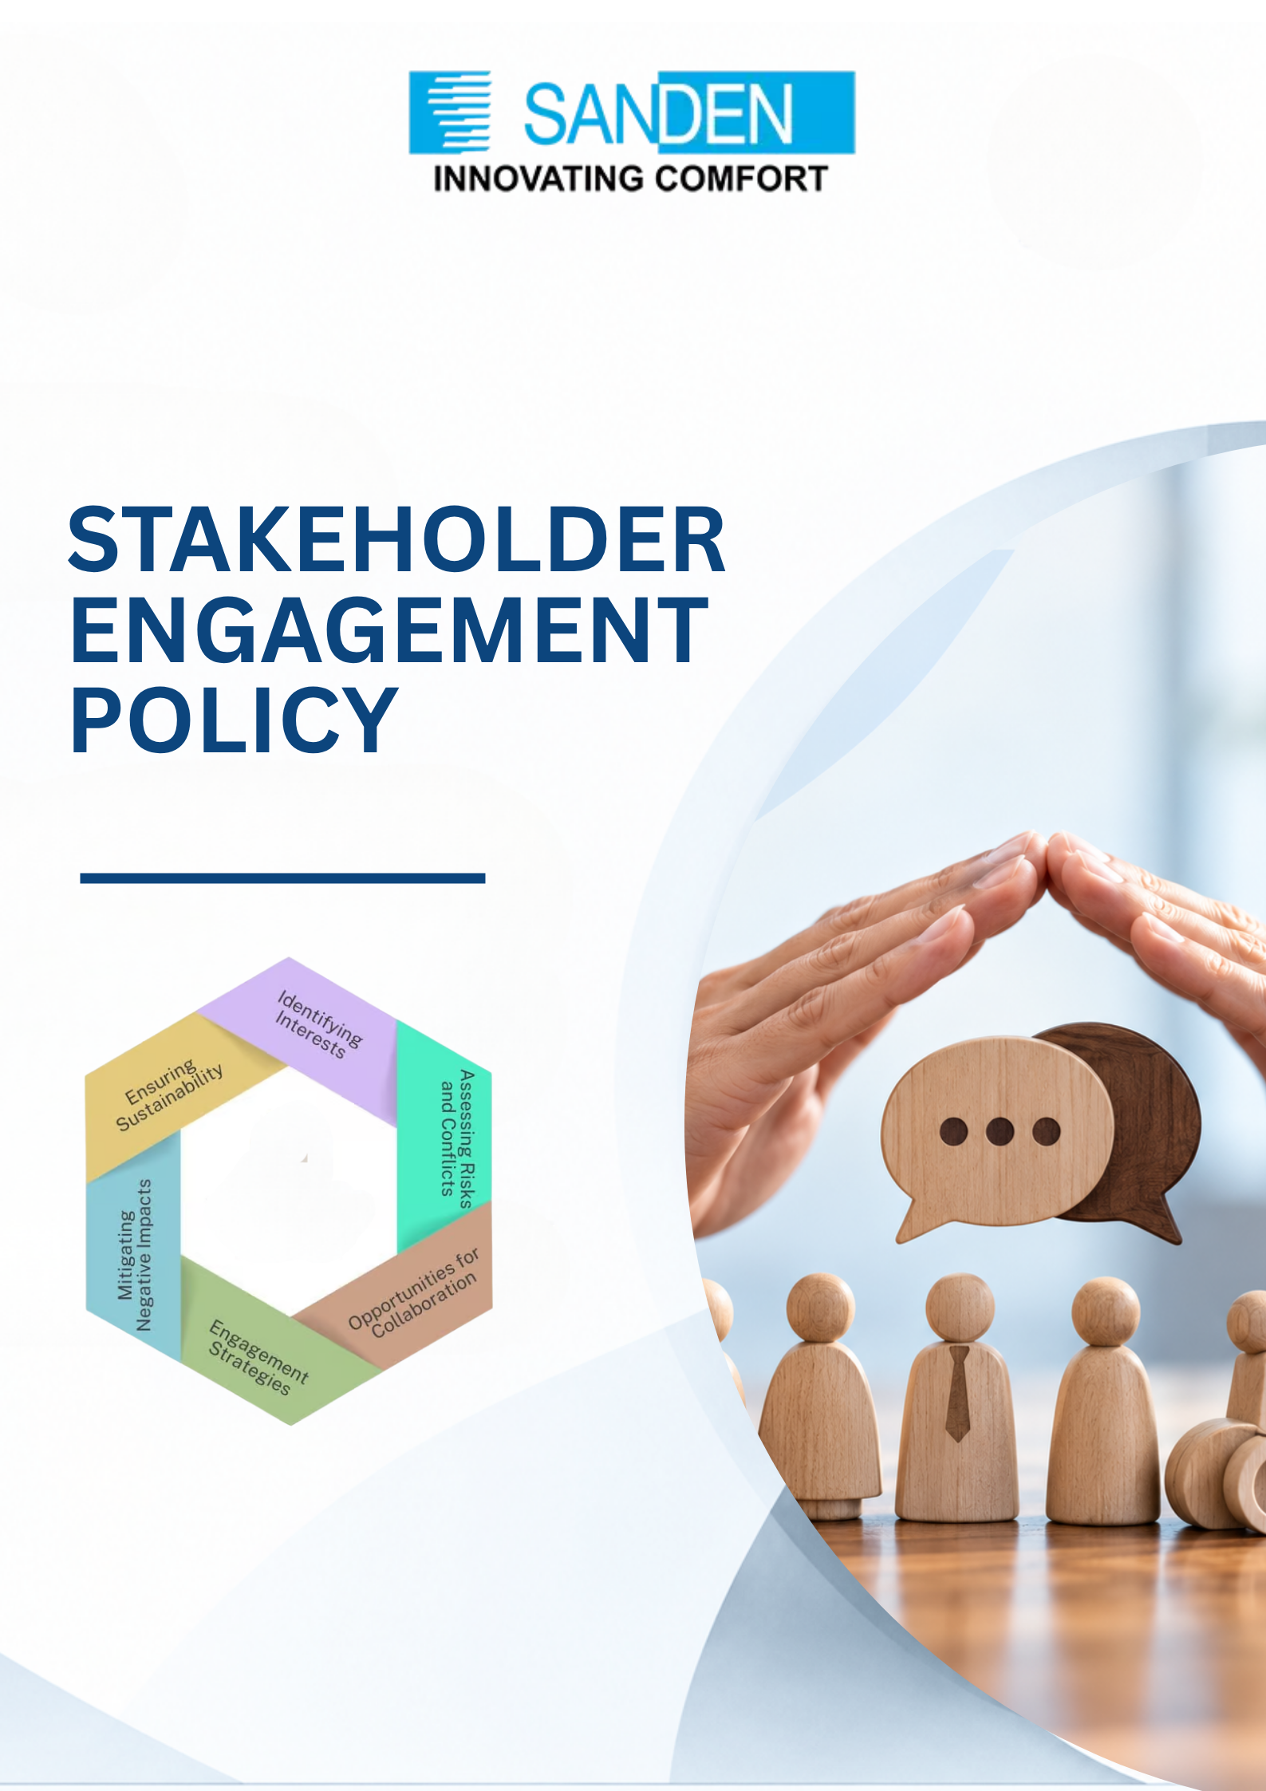

TABLE OF CONTENTS

S. No. | Topic
1 | PREFACE
2 | APPLICABILITY
3 | DEFINITIONS, TERMS & ABBREVIATIONS
4 | OBJECTIVES
5 | STAKEHOLDER IDENTIFICATION
6 | KEY STAKEHOLDER GROUPS
7 | STAKEHOLDER ENGAGEMENT MATRIX
8 | STAKEHOLDER ENGAGEMENT MATRIX
9 | REVIEW AND UPDATES
10 | MONITORING AND CONTINUOUS IMPROVEMENT

STAKEHOLDER ENGAGEMENT POLICY

1. PREFACE
Sanden Vikas (India) Private Limited recognizes that meaningful and transparent engagement with its stakeholders is essential for building trust, understanding stakeholder expectations, identifying emerging risks and opportunities, and creating sustainable long-term value.

The purpose of this Stakeholder Engagement Policy (“Policy”) is to establish a structured, consistent and accountable approach for identifying, prioritizing, engaging with and responding to Sanden Vikas’s stakeholders through transparent, inclusive and responsive communication.

The policy supports Sanden Vikas in understanding stakeholder needs, interests, expectations and concerns, identifying opportunities and risks arising from stakeholder feedback, incorporating relevant stakeholder insights into business decisions, sustainability priorities, risk management processes and long-term value creation initiatives; and strengthening relationships based on trust and mutual benefit.

Sanden Vikas and its companies are committed to maintaining open, respectful, transparent and responsible relationships with its stakeholders. The group will provide appropriate and accessible channels through which stakeholders can communicate their expectations, concerns, feedback and grievances.

This policy is intended to promote consultative and collaborative engagement, active listening, equitable treatment of stakeholders, timely communication and effective follow-up on material matters raised through engagement.

2. APPLICABILITY
This policy applies to all Sanden Vikas companies and extends across all business units, plants, offices, warehouses, project sites, and other operating locations. Each business unit and operating location shall undertake stakeholder engagement in accordance with the principles and requirements of this policy and shall foster transparent, constructive, and mutually beneficial relationships with stakeholders relevant to its operations.

3.DEFINITIONS, TERMS AND ABBREVIATIONS
- Stakeholder: Any individual, group, organization or institution that may affect, be affected by, or perceive itself to be affected by Sanden Vikas’s activities, products, services, decisions or performance.
- Employee: Any person employed by Sanden Vikas, whether on a permanent, probationary, temporary, contractual, trainee, apprentice, consultant, retainer or other work arrangement, and including workers and personnel engaged at any unit, plant, office, project site or operating location of the Company, as applicable.
- Stakeholder Engagement: The process through which Sanden Vikas identifies, communicates with, consults, listens to, responds to and collaborates with stakeholders to understand their legitimate needs, interests, expectations and concerns.

4. OBJECTIVES

Sanden Vikas’s stakeholder engagement process aims to:

i. Understand stakeholder expectations, concerns and priorities.

ii. Build and maintain constructive relationships.

iii. Identify actual and potential impacts of Sanden Vikas’s activities.

iv. Identify ESG, operational, reputational and business risks and opportunities.

v. Improve products, processes and services through stakeholder feedback.

vi. Support informed business and sustainability decision-making.

vii. Identify issues that may be relevant to Sanden Vikas’s sustainability priorities.

viii. Strengthen employee engagement and organizational culture.

ix. Improve supplier and business partner relationships.

x. Support responsible community development.

xi. Provide appropriate mechanisms for raising concerns and grievances.

xii. Promote continuous improvement in stakeholder relationships and Company performance.

5. STAKEHOLDER IDENTIFICATION
Sanden Vikas shall identify stakeholders at both the Group level and the individual company, business unit, plant, office, project site, warehouse, and other operating-location levels, based on the nature and extent of their relationship with the Group and the specific operations, activities, impacts, and relationships associated with each operating location.
Stakeholders may be identified and categorized based on factors including:
- Degree of impact from Sanden Vikas’s operations, activities, products, and services
- Level of influence on Sanden Vikas’s activities, decisions, and operations
- Degree of dependency on Sanden Vikas
- Level of interest in Sanden Vikas’s activities, performance, and sustainability matters
- Nature, significance, and duration of the relationship
- Geographic proximity to Sanden Vikas’s operating locations
- Potential risks and opportunities associated with the stakeholder relationship
- Other relevant business, operational, social, environmental, and sustainability considerations
The stakeholder list shall be reviewed periodically at the group, company, functional, business unit, and operating-location levels and updated, as necessary, to reflect changes in operations, stakeholder expectations, local context, business priorities, and material ESG and sustainability issues.

6. KEY STAKEHOLDER GROUPS
Sanden Vikas’s key stakeholder groups may include, but are not limited to:

Stakeholder Group | Examples
Employees & Workers | Permanent employees, contractual workers, trainees, apprentices, and other workforce categories across Sanden Vikas companies and operating locations
Customers | OEM customers, business customers and other customers
Suppliers & Business Partners | Raw material suppliers, service providers, logistics partners and contractors
Shareholders / Owners | Shareholders, promoters and other ownership representatives
Management & Leadership | Board, senior management and functional leadership
Government & Regulatory Authorities | Central, State and local authorities and regulatory bodies
Local Communities | Communities located around Sanden Vikas’s plants, offices, project sites, and other operating locations
Financial Stakeholders | Banks, lenders and other relevant financial stakeholders
Industry & Business Associations | Relevant industry associations and business forums
Civil Society / NGOs | Non-governmental organisations and community organisations
Academic / Technical Institutions | Educational institutions, research organisations and technical partners
Other Stakeholders | Any other stakeholder group identified as relevant to Sanden Vikas’s activities, operations, business relationships, or sustainability priorities
The relevance and significance of each stakeholder group may vary depending on the nature, scale, location, and potential impact of Sanden Vikas’s activities, as well as the specific context of each company, business unit, plant, office, project site, warehouse, or other operating location.

Stakeholder Engagement Process

Sanden Vikas shall follow a structured four-stage stakeholder engagement process to ensure that stakeholder interactions are systematic, inclusive, transparent, and responsive.

7.1 Identify & Prioritize

Identify relevant stakeholders and prioritize them based on their impact, influence, dependency, interest and vulnerability to determine the appropriate level and frequency of engagement.

7.2 Engage & Understand

Engage stakeholders through appropriate channels to understand their expectations, concerns, feedback, risks and opportunities, while ensuring inclusive, respectful and transparent dialogue.

7.3 Respond & Integrate

Evaluate stakeholder feedback and, where relevant, incorporate it into business decisions, policies, programmes, risk management and sustainability initiatives. Actions shall be assigned and tracked to closure.

7.4 Monitor, Report & Review

Monitor engagement outcomes and action progress, communicate relevant outcomes where appropriate, and periodically review and improve the stakeholder engagement approach based on feedback, emerging issues and changing stakeholder expectations.

Framework:

Step | Title | Key Actions
1 | Identity & Priorities | - Recognize key issues, opportunities, or tasks  - Assess urgency and importance  - Establish priorities for action
2 | Engage & understand | - Connect with stakeholders or data sources  - Gather insights and perspectives  - Build a shared understanding of needs
3 | Respond & integrate | - Develop solutions or actions  - Integrate feedback and align with priorities  - Implement effectively across teams
4 | Monitor, Report & Review | - Track progress and outcomes  - Report findings transparently  - Review for continuous improvement

Stakeholder Engagement Matrix

Sanden Vikas shall engage with its stakeholders through appropriate and accessible channels, considering the nature of the stakeholder relationship, the purpose and objective of the engagement, the stakeholder’s needs and expectations, and the topics under consideration. The indicative stakeholder engagement channels may include:
Stakeholder Group | Engagement Channels
Investor | - One on one meetings  - Annual Shareholders meeting  - Quarterly Investor Presentation  - Monthly communication on results achieved, gaps observed are communicated to the respective investor
Employees & Workers | - Employee surveys and feedback mechanisms  - Intranet Portal  - Training and awareness programmes  - Employee engagement activities – Townhall Meetings, Competitions, Inbound & Outbound Activities, etc.  - Emails, written communication

Stakeholder Group | Engagement Channels
Customers | i. Customer meetings and reviews  ii. Customer Audits  iii. Customer feedback and complaint mechanisms  iv. Marketing and Advertising  v. Phone, Email and written communication
Suppliers & Business Partners | i. Supplier assessments and audits  ii. Meetings/ Communication through phone, email and in-person interactions  iii. Supplier feedback mechanisms  iv. Training and awareness programmes
Community | - CSR intervention and initiatives  - Community grievance system  - NGOs for PwD hirings  - Interaction with colleges, universities for hiring and higher education  - Maintaining social media presence
Government & Regulatory Authorities | - Compliance monitoring and reporting  - Regulatory submissions and communications  - Formal meetings and consultations  - Regulatory inspections and interactions

Principles of Stakeholder Engagement
Sanden Vikas shall conduct stakeholder engagement in accordance with the following principles:

9.1 Transparency

Maintain open, clear, timely, and appropriate communication with stakeholders while ensuring the confidentiality and protection of sensitive or proprietary information.

9.2 Active Listening

Actively understand and consider stakeholder expectations, concerns, feedback, and perspectives, and incorporate relevant inputs into decision-making processes, wherever appropriate.

9.3 Fair and Equitable Engagement

Engage with stakeholders in a fair, respectful, and non-discriminatory manner, recognizing and addressing their diverse needs, interests, and circumstances.

9.4 Inclusiveness
Provide relevant stakeholders with appropriate and accessible opportunities to participate, share their views and raise concerns.

9.5 Responsiveness
Consider and respond appropriately to relevant stakeholder feedback and concerns, with actions proportionate to their significance.

9.6 Collaboration
Build constructive, trust-based and mutually beneficial relationships with stakeholders through dialogue and collaboration.

9.7 Monitoring and Continuous Improvement
Use stakeholder feedback, engagement outcomes, and emerging expectations to strengthen Sanden Vikas’s business practices, sustainability initiatives, risk management processes, and stakeholder relationships. The effectiveness of stakeholder engagement shall be reviewed periodically, and this Policy shall be revised, as required, to remain aligned with the Group’s evolving business and sustainability priorities.

Stakeholder Grievance and Feedback Mechanisms
Sanden Vikas shall provide accessible and appropriate mechanisms for stakeholders to raise queries, concerns, complaints, grievances, feedback or requests for clarification regarding the company’s activities, decisions, operations, products, services or sustainability practices.
Stakeholders may communicate their concerns through designated stakeholder communication channels, including the relevant contact person, function, site representative or official communication email address, as applicable.
All concerns received should be acknowledged, reviewed by the functions concerned and addressed in a fair, timely and appropriate manner. Where necessary, significant, sensitive, repeated or unresolved concerns shall be escalated to the relevant management authority for review and action.
Sanden Vikas shall maintain appropriate confidentiality of information received through the grievance and feedback mechanism, subject to applicable legal, regulatory and business requirements, and shall ensure that stakeholders raising genuine concerns in good faith are treated fairly and protected from retaliation.

7. COMPLIANCE AND LEGAL FRAMEWORK

7.1 DOMESTIC LAWS AND GUIDELINESS (INDIA)
- Companies Act, 2013: Provisions on corporate governance, board composition, audit requirements, and CSR initiatives.
- Securities and Exchange Board of India (SEBI) Regulations: Guidelines for listed companies on corporate governance, disclosures, and investor protection.
- Indian Contract Act, 1872: Governs contracts and agreements within the company.
- Prevention of Corruption Act, 1988: Ensures ethical conduct in business dealings.
- Environment Protection Act, 1986: Encourages sustainable practices.
- The Competition Act, 2002: Aims to prevent anti-competitive practices.

7.2 INTERNATIONAL LAWS
- Japanese Antimonopoly Act, similar laws such as US Antitrust Laws, European Competition Law, Anti-Monopoly Law of China, etc. as per respective country norms.
- The above laws are indicative, laws as per the Policy principles/guidelines will also be complied.

8. REPORTING AND ACCOUNTABILITY

8.1 WHISTLE-BLOWING POLICY
- We encourage employees and stakeholders to report suspected misconduct, unethical behavior, or violations of this policy without fear of retaliation as per “The Vigil Policy”.

8.2 DISCIPLINARY ACTION
- Failure to adhere to this Business Ethics Policy may result in disciplinary action, up to and including termination of employment/business relationships.

9. REVIEW AND UPDATES
- This policy will be reviewed as required to ensure relevance and effectiveness. Updates will be communicated to all stakeholders promptly.
- In case of any doubt please contact the Departmental Head/ HR Head/Legal department for more clarity.

10. MONITORING AND CONTINUOUS IMPROVEMENT
- Training will be conducted to promote awareness and compliance with the policy.
- All employees and stakeholders are expected to understand and uphold the principles outlined in the policy.
- The document is the property of Sanden Vikas, and it is intended for limited circulation as per management discretion.
- Management reserves the right to change or update the policy without prior notice.

