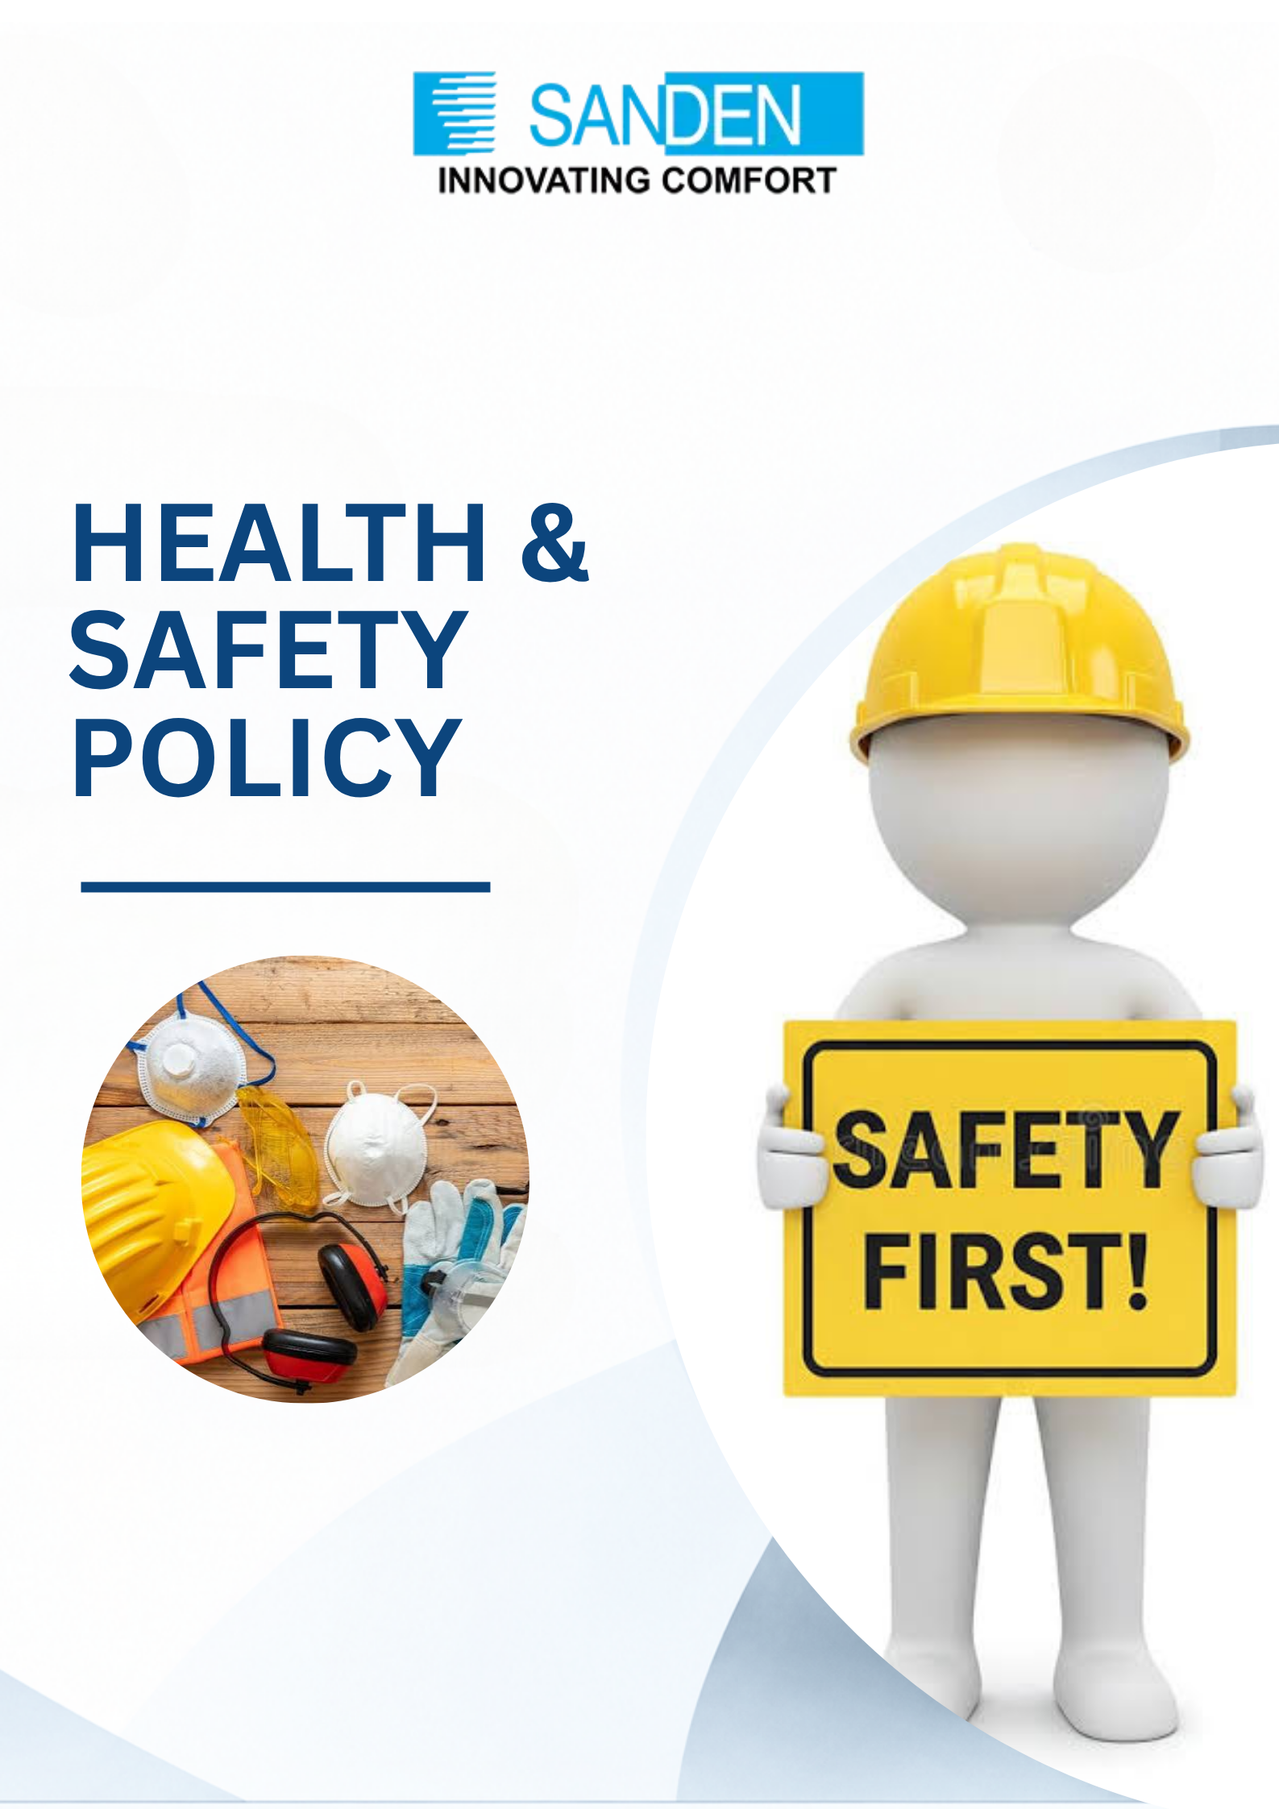

TABLE OF CONTENTS

S. No. | Topic
1 | PREFACE
2 | SCOPE
3 | COVERAGE
4 | IMPLEMENTATION AND MONITORING
5 | COMMUNICATION AND TRAINING
6 | REPORTING AND TRANSPARENCY
7 | REVIEW AND UPDATE

HEALTH AND SAFETY POLICY

PREFACE
Sanden Vikas (India) Private Limited is committed to ensuring the health, safety, and well-being of all its employees, contractors, and visitors through all its operations. The Company recognizes the vital importance of fostering a safe and healthy working environment to minimize accidents, injuries, and occupational illnesses. This policy outlines our commitment to providing a safe workplace, preventing harm, and ensuring compliance with all relevant health and safety laws and regulations.

We aim to ensure that safety is embedded into every aspect of our operations through continuous improvement, training, and employee engagement, in line with the principles of the internationally recognized management system standard ISO 45001 (Occupational Health & Safety Management). By maintaining a proactive approach to health and safety, Sanden Vikas strives to uphold the highest standards of corporate responsibility and provide a safe & secure workplace for all stakeholders.

OUR COMMITMENT TO HEALTH & SAFETY
    - We shall ensure strict adherence to health and safety laws, regulations and other applicable requirements, applicable to our operations.
    - We shall conduct regular risk assessments to identify hazards and mitigate risks proactively.
    - We shall provide employees with the proper tools, equipment, and training to ensure their safety.
    - We shall continually assess workplace safety conditions and take corrective measures to prevent accidents.
    - We shall promote employee involvement in safety initiatives and encourage a zero-tolerance policy towards unsafe behaviors.

SCOPE
This Health & Safety Policy applies to all businesses, units, subsidiaries, and departments of Sanden Vikas. It also extends to contractors, third-party vendors, and business partners who must adhere to our safety practices while operating within our facilities or working on our behalf. This Policy shall be communicated to all employees, contractors, suppliers, customers, and other stakeholders in the local language(s) understood by the workforce.

COVERAGE
This policy covers all aspects of health and safety management across all Sanden Vikas locations and operations.

3.1 HIRA (Hazard identification & Risk Assessment
    - We will ensure periodic hazard identification and risk assessment, with appropriate mitigation and control measures implemented to eliminate or minimise identified health and safety risks.

3.2 PERSONAL PROTECTIVE EQUIPMENT (PPE)
    - We are dedicated to ensuring that appropriate Personal Protective Equipment (PPE) is provided and used by all employees who may be exposed to hazards in the workplace. PPE is an essential part of our safety measures, and employees are required to wear it as per the specific requirements of their roles.

3.3 MACHINE SAFETY
- We prioritize the safety of our employees when working with machinery and equipment. To prevent accidents, we implement stringent machine safety protocols.

3.4 EMERGENCY PREPAREDNESS
- We are committed to ensuring that all employees are prepared to respond effectively to any emergencies that may occur in the workplace. Emergency preparedness is a key aspect of our safety culture.

INCIDENT AND ACCIDENT MANAGEMENT
i. We strive to create a workplace where incidents and accidents are prevented. In the event of any incident or accident, our primary goal is to manage it quickly and effectively to prevent further harm.

WORKPLACE ERGONOMICS
i. We recognize the importance of maintaining a healthy and comfortable workplace to reduce the risk of injury and strain. Proper ergonomics are key to enhancing both safety and productivity.

HANDLING OF CHEMICAL AND BIOLOGICAL SUBSTANCES

i. We are committed to ensure the safe handling, storage, and disposal of all chemicals and biological substances used in our operations. Proper training and precautions will be taken to minimize health risks.

FIRE PROTECTION
i. We are committed to minimizing fire risks and ensuring that all employees are trained to respond to fire emergencies effectively. Fire protection is an essential element of our workplace safety program.

4. IMPLEMENTATION AND MONITORING
- This Health & Safety Policy is an integral part of Sanden Vikas's overall management framework and is mandatory for all units and subsidiaries to implement.
- We will ensure compliance and regularly monitor the effectiveness of safety measures in place.
- We will regularly do Safety Audits, Drills, etc. to ensure effectiveness of the policy.

5. COMMUNICATION AND TRAINING
i. The HR and Health & Safety teams are responsible for implementing comprehensive training programs and promoting awareness regarding health and safety within the organization.

6. REPORTING AND TRANSPARENCY
i. The company will ensure timely, accurate, and transparent reporting of health and safety data to internal and external stakeholders. This includes reporting on injury rates, accidents, and near-miss incidents.

7. REVIEW AND UPDATE
- This Health & Safety Policy shall be reviewed annually by the Health & Safety Committee to ensure its relevance and effectiveness. Updates will be made as necessary based on evolving legal requirements, industry standards and internal or external audits.
- The document is the property of Sanden Vikas, and it is intended for limited circulation as per management discretion.
- Management reserves the right to change or update the policy without prior notice.

