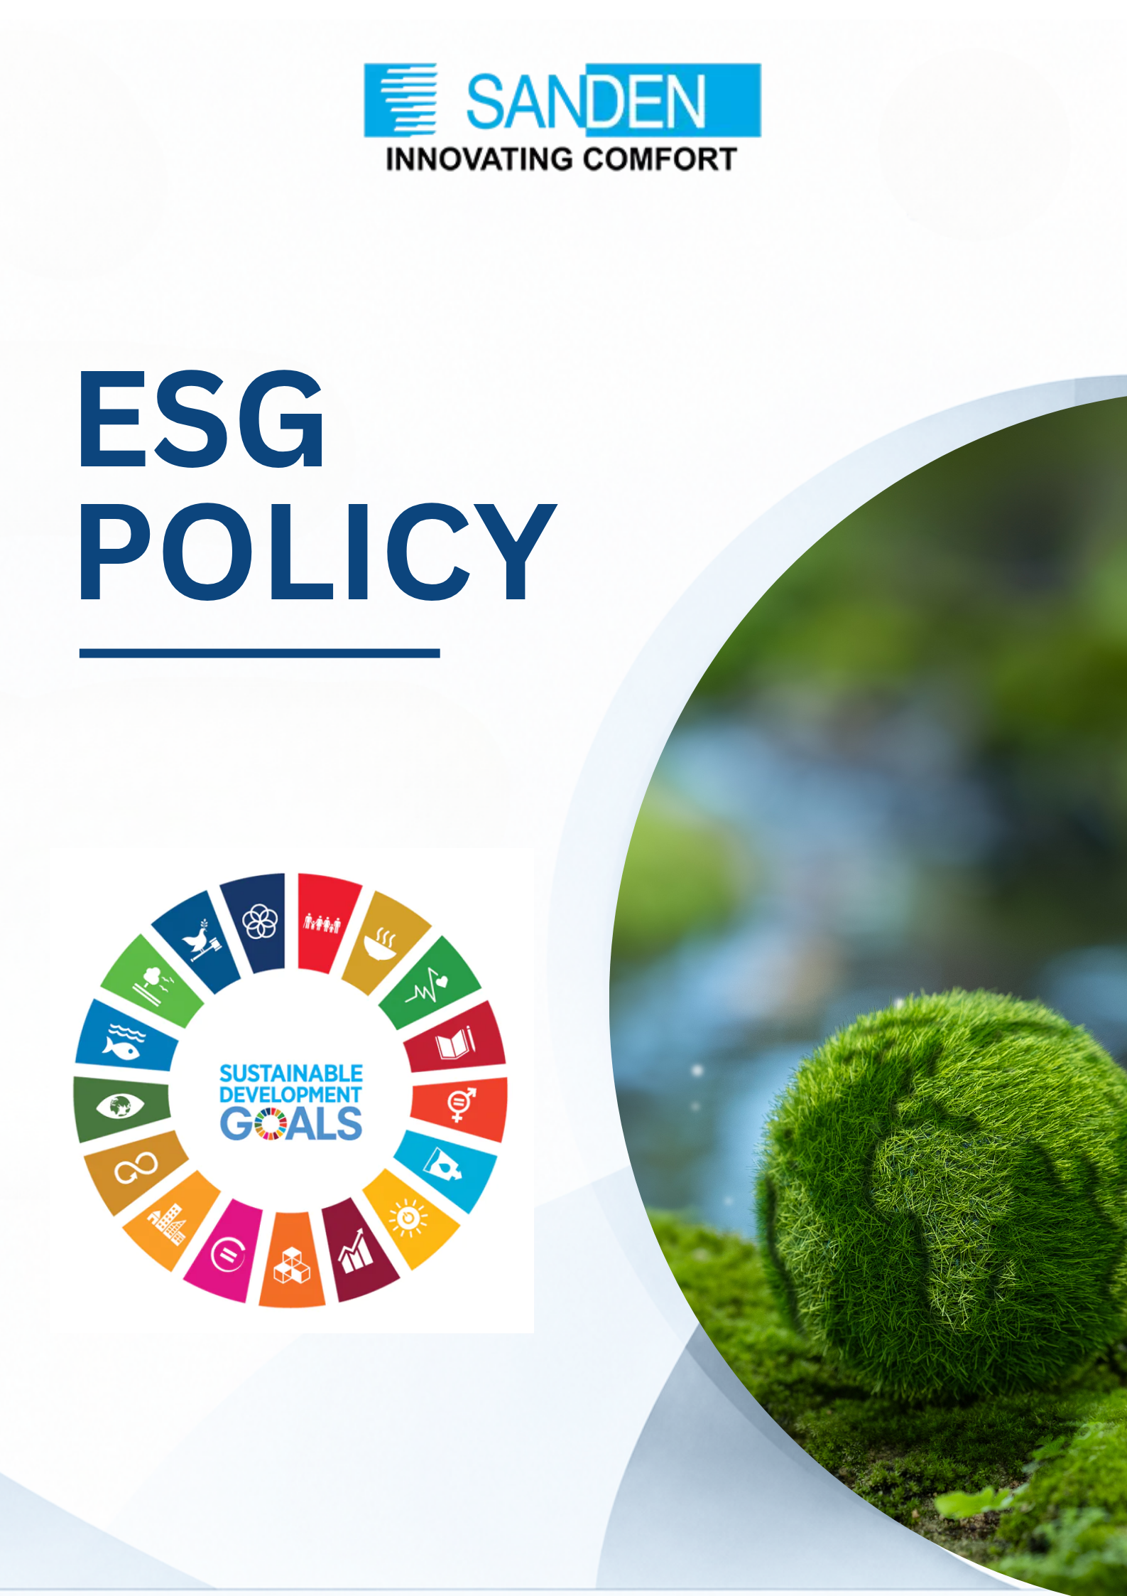

TABLE OF CONTENTS

S. No. | Topic
1 | PREFACE
2 | SCOPE
3 | ENVIRONMENTAL POLICY
4 | SOCIAL POLICY
5 | GOVERNANCE POLICY
6 | IMPLEMENTATION AND MONITORING
7 | COMMUNICATION AND TRAINING
8 | REPORTING AND TRANSPARENCY
9 | REVIEW AND UPDATES
10 | MONITORING AND CONTINUOUS IMPROVEMENT

ESG policy

PREFACE
Sanden Vikas (India) Pvt. Ltd. is committed to building a resilient and sustainable economy through long-term value creation for its stakeholders, society and the nation. We aim to integrate Environmental, Social, and Governance (ESG) considerations into our business strategy, risk management, and operational decision-making processes to ensure sustainable and responsible growth.
This policy is designed to align with national guidelines and internationally recognized sustainability standards and will be progressively updated to reflect evolving best practices. Sustainability and innovation are embedded in our core processes, covering environment, human rights, employee safety and welfare, community engagement, diversity and inclusion, and supply chain responsibility.

SCOPE
This Policy applies to all the units/Offices/ Warehouses of Sanden Vikas. It also extends to our value chain partners including suppliers, contractors, and service providers, who are expected to comply with the principles outlined herein. Furthermore, we expect our business partners, including our suppliers and customers, to comprehend and agree with this Policy and cooperate with us in ensuring that their business operations align with it.

ENVIRONMENTAL POLICY
At Sanden Vikas, we recognize the importance of protecting the environment and are committed to integrating sustainable practices into all aspects of our operations. This section of the ESG Policy outlines our dedication to reducing our environmental impact and to creating a green future.

COMMITMENT TO THE ENVIRONMENT
    - We shall comply with all applicable environmental laws, regulations, and standards in the regions where we operate.
    - We shall continuously monitor our GHG emissions and strive to reduce the emission intensity year on year.
    - We are committed to optimizing resource consumption, including energy, water, and raw materials.
    - We shall strive to prevent pollution by implementing the best practices in waste management through 3R (Reduce, Recycle, Reuse) principles, air emissions control and preventing soil degradation.
    - We shall develop and promote products and services with green technologies that contribute to sustainability and environmental protection.
    - We shall make efforts to protect and preserve biodiversity and support conservation initiatives.
    - We shall be advocating on climate changes and environmental protection.
    - We shall integrate ESG considerations into product design, capital investments, procurement practices, and operational processes.
    - We shall implement environmental management systems (such as ISO 14001 or equivalent frameworks) to track, manage, and improve environmental performance.
    - We shall assess and manage climate related risks and opportunities, including transition and physical risks.

ENVIRONMENTAL GOALS FROM BASE YEAR 2023-24
    - 50% Reduction in Scope 1 & Scope 2 by 2030
    - Reduction in Energy Intensity by 5% year on year
    - Increase in renewable energy share up to 50% of total energy consumption by 2030
    - 30% Reduction in Fresh Water Consumption by 2030
    - Water Neutral by 2030
    - Zero Waste to Landfill by 2030

SOCIAL POLICY
At Sanden Vikas, we are committed to fostering a positive social impact through ethical practices, community engagement, and initiatives that promote well-being and inclusivity. We aim to continuously improve the working environment to maintain and enhance the safety and health of all our employees. We embrace diversity and have zero tolerance for any forms of discrimination and harassment. By adhering to this section of the ESG Policy, Sanden Vikas reaffirms its commitment to building a more inclusive, equitable, and socially responsible future.

COMMITMENT TO SOCIAL PRACTICES
    - We uphold the highest standards of labour practices, including fair wages, safe working conditions and the prevention of forced or child labour.
    - We are dedicated to creating a workplace culture that values diversity and promotes equal opportunities for all.
    - We shall have zero tolerance against discrimination, harassment, or exclusion based on race, gender, age, religion, disability or any other characteristic.
    - We prioritize the health, safety and well-being of all our employees and shall extend these standards of health, safety, and welfare to contract workers and supply chain partners.
    - We are committed to investing in continuous skill development among all our employees.
    - We shall support initiatives focused on education, healthcare, skill development, and infrastructure improvement through CSR & Voluntary activities.
    - vii. We shall respect and promote human rights in accordance with internationally recognized standards such as ILO conventions and the Universal Declaration of Human Rights.
    - We shall establish a grievance redressal mechanism accessible to employees, contractors, and stakeholders.
    - We shall promote product responsibility, ensuring safety, quality, and compliance across the product lifecycle.

SOCIAL GOALS
    - Improve Diversity Ratio to 30% by 2030.
    - Minimum 32 manhours training/ employee every year.
    - Promote and advocate the ESG responsible practices among our stakeholders, including employees, suppliers, contractors, business partners, and other relevant stakeholders, through awareness, engagement, training, and capacity-building initiatives.

GOVERNANCE POLICY

At Sanden Vikas, we are committed to implementing robust governance practices that promote accountability, transparency and ethical decision-making at all levels of the organization. We shall comply with National, International laws and regulations applicable at our area of operations and strive to practice transparent and fair corporate management.

5.1 COMMITMENT TO GOVERNANCE
    - We shall establish a comprehensive compliance framework to ensure adherence to applicable laws, regulations, and internal policies.
    - We shall create & comply with the policies confirming the National Guidelines on Responsible Business Conduct (NGRBC).
    - We shall engage with stakeholders regularly to understand their concerns and incorporate their feedback into governance practices.
    - We shall conduct regular audits to ensure compliance with governance standards and identify areas for improvement.
    - We shall make financial and non-financial disclosures in a transparent, accurate and timely manner.
    - We shall support and strive for responsible & sustainable Supply Chain.
    - We shall integrate ESG considerations into enterprise risk management (ERM) to identify, assess, and mitigate ESG-related risks.
    - We shall maintain a Code of Conduct and anti-corruption framework applicable across the organization and value chain.
    - We shall ensure data privacy, cybersecurity, and ethical use of information systems.

5.2 GOOD GOVERNANCE GOALS
    - Zero Statutory Complaints/ Fines.
    - Publish Sustainability Report as per BRSR framework.
    - 100% awareness of NGRBC among Senior Management & Board of Directors.
    - Sustainability Audits of 80 % of our upstream value chain partners by 2030.

IMPLEMENTATION AND MONITORING
This policy forms an integral part of Sanden Vikas's Sustainability Framework and is mandatory for all units/companies within the organization to implement.
- We shall regularly review and improve our ESG goals to align with evolving sustainability goals and industry standards.
- We shall track and report on our performance metrics to measure progress and identify areas for improvement.
- ESG KPIs shall be integrated into functional performance metrics wherever applicable.
- Internal audits and periodic reviews shall be conducted to ensure compliance and continuous improvement.

COMMUNICATION AND TRAINING
    - The HR and ESG team shall assume responsibility for training and promoting

awareness of this Policy and ESG Goals.
    - ESG awareness programs shall be extended to suppliers and key stakeholders to ensure wider adoption across the value chain.

REPORTING AND TRANSPARENCY
    - We shall prepare and publish a Sustainability / ESG Report in line with recognized frameworks such as BRSR, GRI or other applicable standards.
    - Sanden Vikas shall progressively enhance disclosure quality, data accuracy, and transparency, including consideration of third-party assurance.

REVIEW AND UPDATE
- The policy shall be reviewed and updated by ESG Steering Committee as and when required
- Management reserves the right to change or update the policy without prior notice.
- Policy updates shall also consider regulatory changes, stakeholder expectations, and evolving ESG best practices globally.

GOVERNANCE STRUCTURE

Sustainability Management Framework
  - A structured framework for sustainability governance, review, and approval

Cross Functional Team (CFT)
HR, EHS, Finance, Operations, Utilities, Maintenance, PE, R & D, Admin
.

Supervising Executive Council
Plant head, HR Head, Quality Head, Admin Head, Safety Head, etc.

Sustainability Management Committee
Abhimanyu Sharaff (ED), Ryuhei Ushikubo (JMD),
Tanu Ahuja (ESG & Sustainability Head), Puneet Jain (Finance Head)

Committee Member Responsibilities  - Carbon Neutral Strategy  - Water Neutral Strategy  - Carbon Offsetting  - Carbon Credits  - RE100  - Policy Formation and Execution  - Sustainability Framework  - Compliance Assurance  - CSR | Responsibilities of Executive Council & CFT  - Material Efficiency  - Energy Efficiency  - Logistics  - Packaging  - Water Efficiency  - Employee Engagement activities related to ESG


