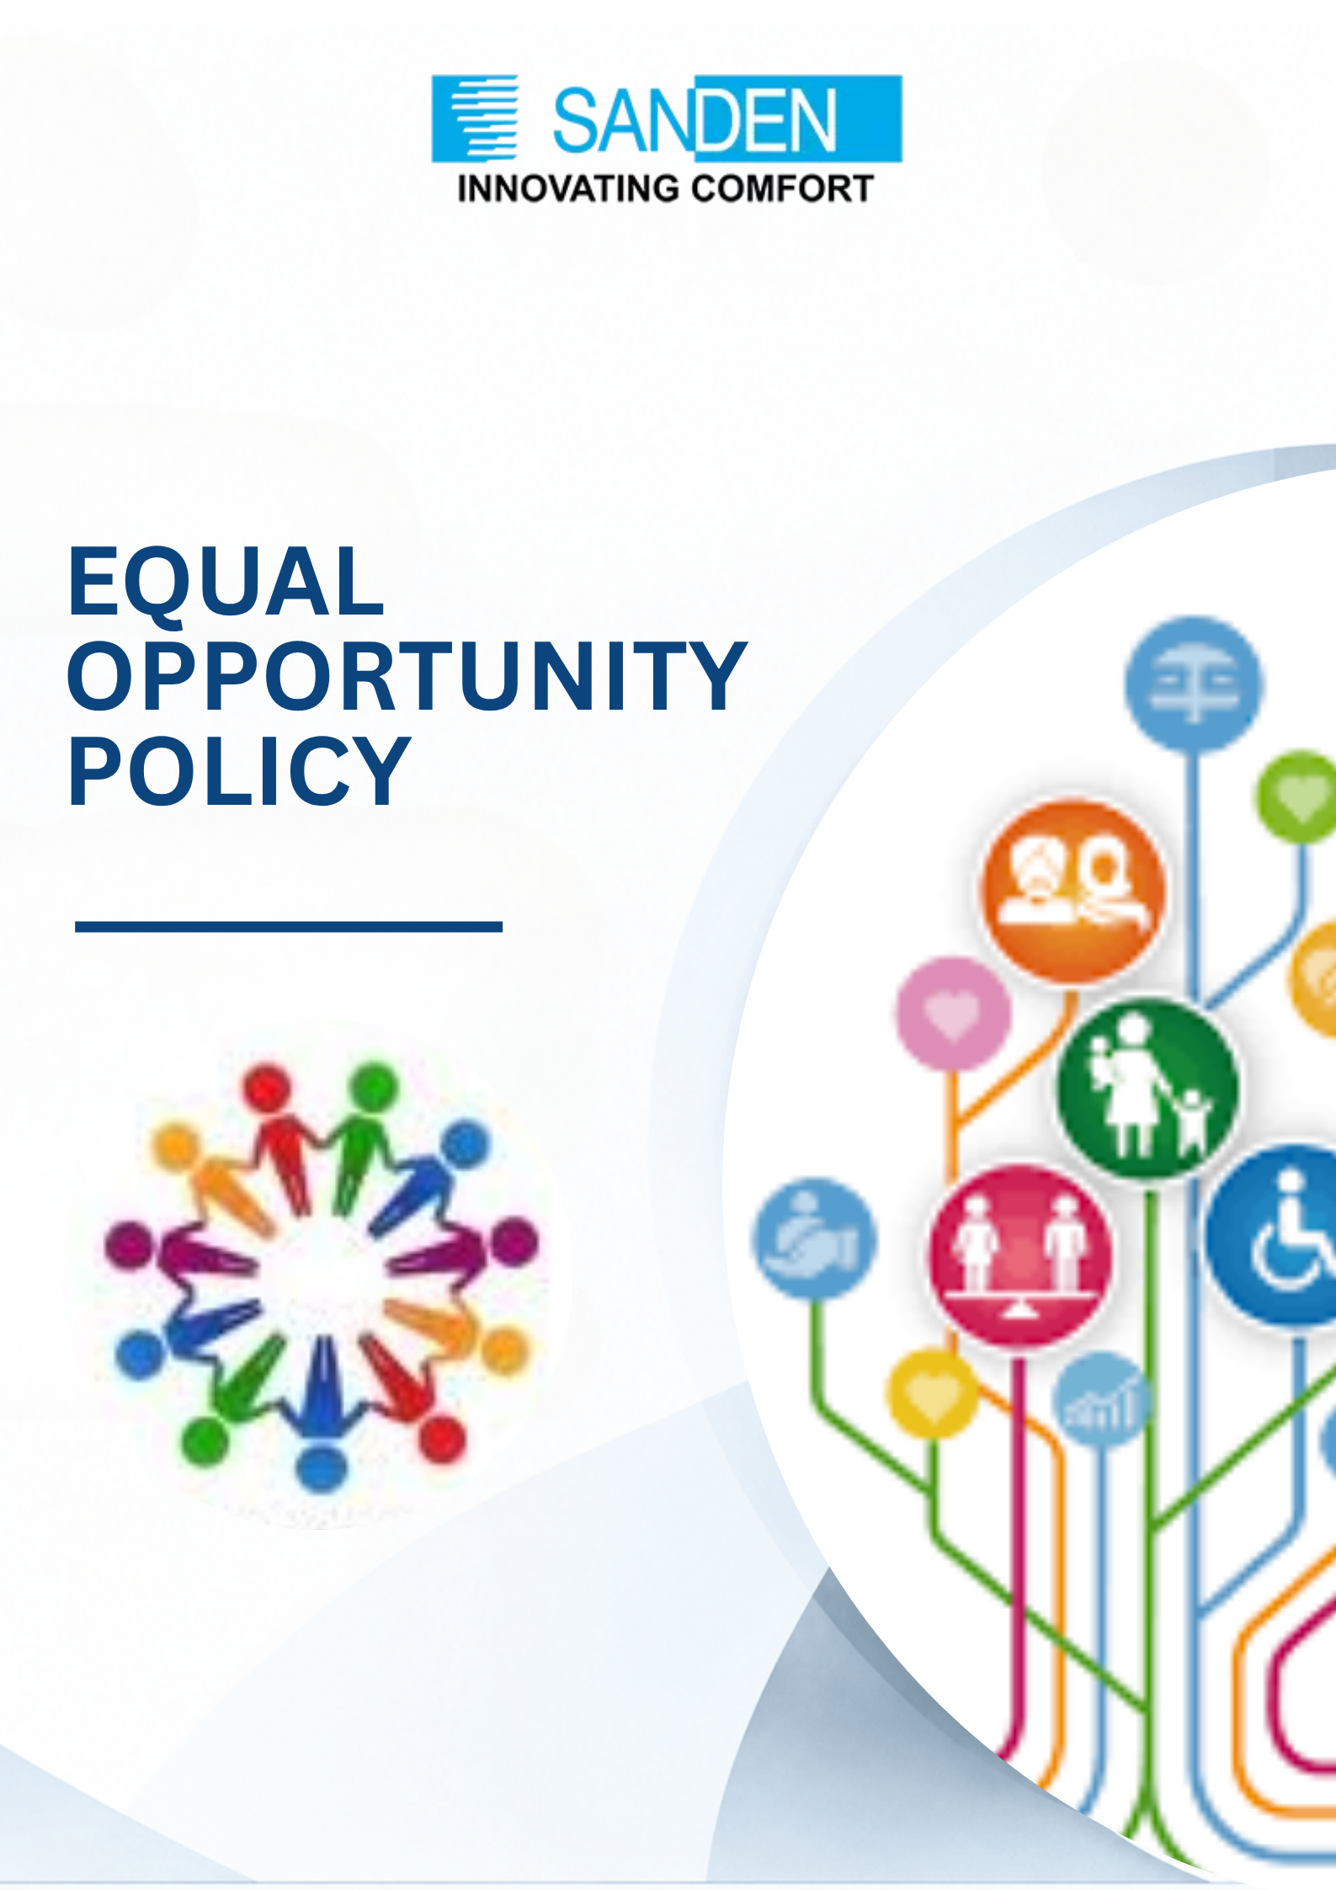

TABLE OF CONTENTS

S. No. | Topic
1 | PREFACE
2 | OBJECTIVE
3 | SCOPE
4 | POLICY STATEMENT
6 | COMMITMENT TO EQUAL OPPORTUNITY
7 | NON-DISCRIMINATION
8 | INCLUSION AND ACCESSIBILITY  SELECTION, TRAINING, AND FACILITIES
9 | RESPONSIBILITIES
10 | GRIEVANCE REDRESSAL
11 | IMPLEMENTATION AND MONITORING
12 | TRAINING AND AWARENESS
13 | REVIEW AND UPDATES

EQUAL OPPORTUNITY policy

1. PREFACE
Sanden Vikas (India) Private Limited is committed to fostering a fair, inclusive, respectful and diverse workplace where all individuals are treated with dignity and provided equal opportunities in employment and professional development. The Group believes that diversity and inclusion strengthen organizational culture, innovation, employee engagement and long-term business sustainability.

This policy has been framed in accordance with the provisions of the Rights of Persons with Disabilities Act, 2016 and the Rights of Persons with Disabilities Rules, 2017, as well as other applicable laws, reflecting Sanden Vikas’s commitment to equal opportunity and maintaining a workplace free from discrimination, harassment, intimidation, and unfair treatment.

2. OBJECTIVE
- Promote equal opportunity and fair treatment across all employment practices.
- Prevent discrimination, harassment and exclusion in the workplace.
- Foster an inclusive and respectful working environment for all employees and stakeholders.
- Encourage diversity, equity, accessibility and inclusion across Sanden Vikas operations.
- Ensure compliance with applicable legal and regulatory requirements related to equal opportunity and workplace inclusion.

3. SCOPE

This policy applies to all employees, directors, trainees, apprentices, consultants, contract workers, job applicants, vendors, service providers and other stakeholders associated with Sanden Vikas.

The policy shall be applicable across all business units, offices, plants and operational locations of Sanden Vikas.

4. POLICY STATEMENT
Sanden Vikas is an equal opportunity employer and is committed to providing a workplace that promotes fairness, equality, dignity and respect for all individuals.

Employment-related decisions including recruitment, hiring, training, compensation, promotion, transfers, career development and separation shall be based on merit, qualifications, experience, performance and business requirements without discrimination of any kind.

5. COMMITMENT TO EQUAL OPPORTUNITY
- Provide equal employment opportunities to all eligible individuals.
- Ensure recruitment and employment practices are conducted fairly and transparently.
Provide equal opportunities for learning, development and career advancement based on merit and performance.
- Encourage workplace diversity and inclusion across all levels of the organization.
- Provide reasonable support and workplace accommodation for persons with disabilities or employees with special needs, wherever feasible and appropriate.
- Ensure workplace facilities, infrastructure, and digital systems are progressively made accessible in line with applicable accessibility standards.
- vii. Maintain a workplace environment that is safe, inclusive, accessible and respectful for all employees.

6. NON-DISCRIMINATION

Sanden Vikas shall not tolerate discrimination, harassment, victimization or unfair treatment on the basis of:

i. Gender

ii. Age

iii. Religion

iv. Caste

v. Race or ethnicity

vi. Nationality

vii. Disability

viii. Marital status

ix. Sexual orientation

x. Social background

xi. Any other characteristic protected under applicable laws

7. INCLUSION AND ACCESSIBILITY

Provide facilities and amenities to people with disabilities to enable them to effectively discharge their duties.

Ensure workplace practices, facilities, and systems are developed with consideration towards accessibility and inclusion.

Maintain a list of posts identified as suitable for persons with disabilities, which shall be reviewed periodically.

Ensure barrier free accessibility in physical infrastructure and digital systems, and provide assistive devices wherever required.

Encourage an inclusive culture where all individuals are respected and valued.

Prohibit retaliation against any individual raising concerns related to discrimination or harassment.

8. SELECTION, TRAINING, AND FACILITIES

Persons with disabilities shall be considered for recruitment to identify suitable posts through fair and transparent selection processes.

Post recruitment and pre-promotion training opportunities should be provided to enable career growth.

Preference may be given in transfer, posting, special leave, and allotment of residential accommodation, wherever applicable.

Additional facilities and support shall be extended to ensure effective discharge of duties.

9. RESPONSIBILITIES
9.1 Responsibilities of Management
- Promote and uphold the principles of equal opportunity and inclusion.

Ensure fair and unbiased employment practices.

Address workplace concerns, complaints or grievances in a timely and appropriate manner.

Appoint a Liaison Officer to oversee recruitment, training, and career development of persons with disabilities, and to ensure compliance with the Rights of Persons with Disabilities Act, 2016.

Promote awareness regarding workplace dignity, diversity and inclusion.

9.2 Responsibilities of Employees
- Treat colleagues, stakeholders and business partners with dignity and respect.
- Refrain from discriminatory, offensive, intimidating or harassing behaviour.
- Support and contribute towards an inclusive work environment.
- Report incidents of discrimination, harassment or unfair treatment through appropriate channels.

10. GRIEVANCE REDRESSAL
- Employees or stakeholders who believe they have experienced discrimination, harassment or unfair treatment may report the concern to the HR Department, Liaison Officer, or designated management representative.
- All complaints shall be handled confidentially, fairly and without retaliation.
- Appropriate inquiry and corrective actions shall be taken based on the nature and severity of the concern.
- False, malicious or misleading complaints may also be subject to appropriate action.

11. IMPLEMENTATION AND MONITORING
- The HR Department and Liaison Officer shall be responsible for implementation, communication and monitoring of this Policy.
- Periodic reviews and assessments may be conducted to evaluate compliance and effectiveness of the Policy.
- Any violation of this Policy may result in disciplinary action in accordance with applicable Group’s rules and procedures.
iv. Sanden Vikas shall continue to strengthen workplace practices that support diversity, equity and inclusion.

12. TRAINING AND AWARENESS
- Conduct awareness and sensitization initiatives related to equal opportunity, diversity and workplace inclusion.
- Provide training on respectful workplace behaviour, anti-discrimination principles, accessibility, and grievance reporting mechanisms.
- Encourage continuous improvement in workplace culture through awareness and engagement initiatives.

13. REVIEW AND UPDATE

- This Policy shall be reviewed periodically or whenever required due to changes in business operations, organizational requirements or applicable laws.
- The document is the property of Sanden Vikas and is intended for limited circulation as per management discretion.
- Management reserves the right to amend, modify or withdraw this Policy without prior notice.
- This Policy shall be published on the Group’s/Company’s website, and the web-link shall be disclosed in statutory filings as required under BRSR.

9. REVIEW AND UPDATES
- This policy will be reviewed as required to ensure relevance and effectiveness. Updates will be communicated to all stakeholders promptly.
- In case of any doubt please contact the Departmental Head/ HR Head/Legal department for more clarity.

10. MONITORING AND CONTINUOUS IMPROVEMENT
- Training will be conducted to promote awareness and compliance with the policy.
- All employees and stakeholders are expected to understand and uphold the principles outlined in the policy.
- The document is the property of Sanden Vikas, and it is intended for limited circulation as per management discretion.
- Management reserves the right to change or update the policy without prior notice.

