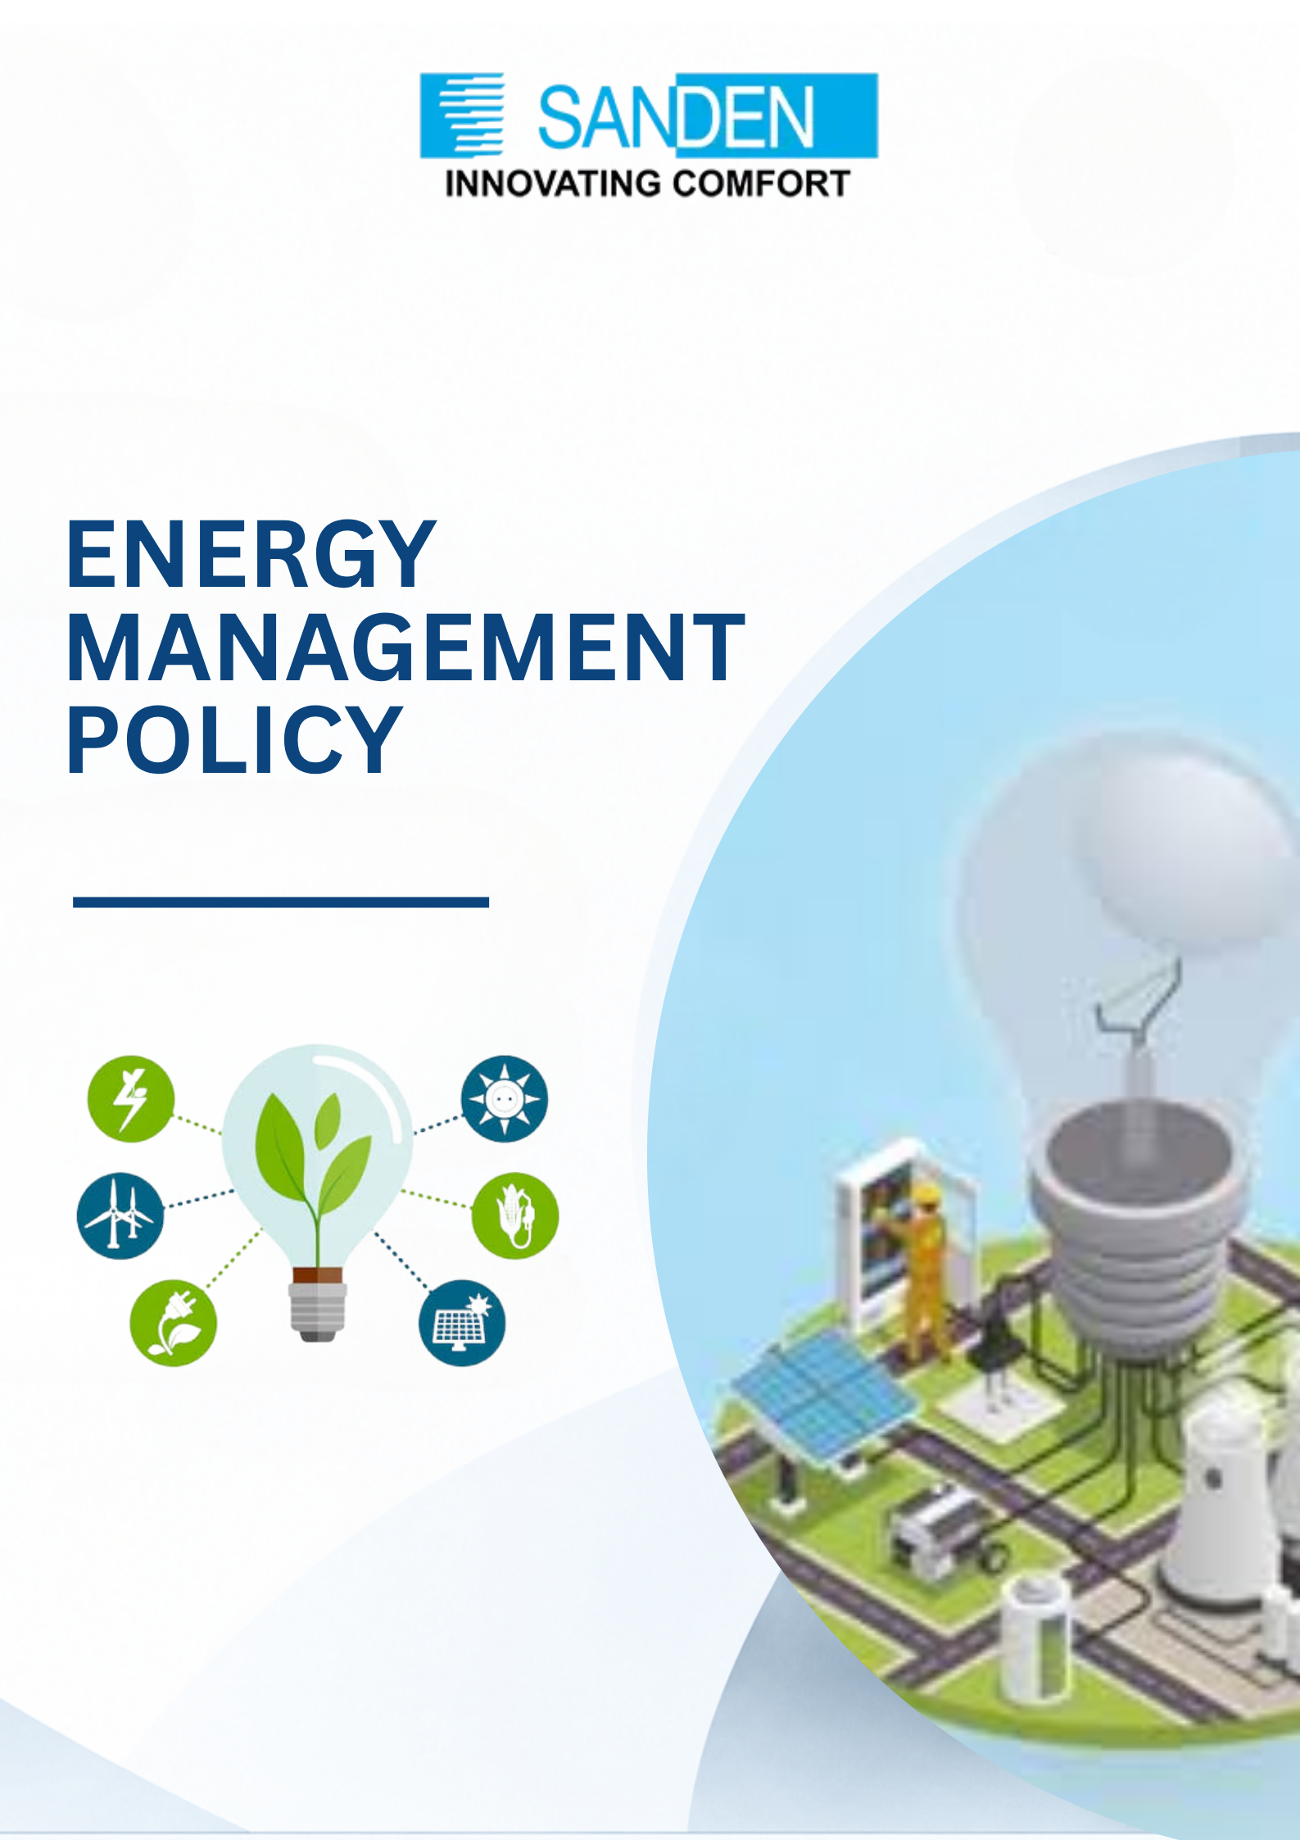

TABLE OF CONTENT

S. No. | Topic
1 | PREFACE
2 | SCOPE
3 | POLICY COMMITMENTS
4 | COMMUNICATION AND TRAINING
5 | MONITORING & REPORTING
6 | REVIEW AND UPDATE

ENERGY MANAGEMENT POLICY

1. PREFACE
Sanden Vikas (India) Private Limited recognizes that energy is a critical input to its operations and a key lever for environmental stewardship, cost competitiveness, and long-term business sustainability.
This Energy Management Policy (“the Policy”) sets out Sanden Vikas’s commitment to the efficient, responsible, and sustainable use of energy across its compressor, HVAC, and Hose & Pipe manufacturing facilities. The Policy also reaffirms our alignment with national priorities such as India’s Net Zero, energy efficiency and decarbonization objectives, including increased penetration of Renewable Energy.

1.1 Our Commitment to Energy Management
- We shall ensure strict adherence to energy management laws and regulations applicable to our operations.
- We shall conduct regular energy audits to identify inefficiencies and opportunities for improvement proactively.
- We shall provide employees with the proper tools, training, and technologies to support energy-efficient working.
- We shall continually assess energy performance across all facilities and take corrective measures to reduce wastage.
- We shall promote employee involvement in energy conservation initiatives and encourage responsible energy-use behaviour.

2. SCOPE
- This Policy applies to all businesses, units, subsidiaries, or holding company of Sanden Vikas.
- The Policy applies to all employees, contract workers, and, where relevant, suppliers, contractors, service providers, and other value chain partners whose activities may influence or contribute to Sanden Vikas's energy consumption, energy efficiency, and overall energy performance.

3. POLICY COMMITMENTS

3.1 Compliance and Governance
- Achieve and maintain compliance with all applicable legal, statutory, and other requirements relating to energy use, consumption, and efficiency, including the Energy Conservation Act, 2001
- Promote the efficient use of energy in the design, manufacture, and delivery of world-class thermal management products, including compressors, HVAC units, and Hose & Pipe assemblies, to our customers.
- Align our energy management practices with the principles of ISO 50001 (Energy Management Systems), and work towards formal certification across manufacturing facilities where feasible.

3.2 Strategic Energy Management
- Continuously improve energy efficiency on the Compressor, HVAC, and Hose & Pipelines through best-available technologies, including energy-efficient motors, Variable Frequency Drives (VFDs), compressed-air optimisation, and LED/BEE star-rated equipment.
- Conduct periodic energy audits to evaluate performance, identify improvement opportunities, and track corrective actions.
- Set, monitor, and review energy efficiency objectives and targets aligned with business goals and regulatory requirements, tracked through defined Energy Performance Indicators (EPIs).

3.3 Renewable Energy Adoption
- Progressively reduce dependence on fossil fuel-based energy by increasing the share of solar and other renewable sources in Sanden Vikas’s energy mix, including rooftop solar and green power procurement where feasible.
- Support India’s Net Zero and decarbonization goals through phased adoption of clean energy across facilities.

3.4 Employee Awareness and Capability Building
- Build energy-conscious behaviour among all employees through regular training and awareness programmes.
- Encourage employee suggestions and participation in identifying energy-saving opportunities on the shop floor and in offices.

3.5 Energy Efficiency in Design, R&D and Procurement
- Integrate energy-efficiency considerations into product design and development within the Design & Development and Testing & Validation functions.
- Embed energy efficiency into facility planning, equipment selection, and procurement decisions.
- Procure adequate, reliable, and where possible renewable energy supplies on the most advantageous commercial terms and promote green procurement practices with suppliers.

3.6 Stakeholder Engagement
- Engage employees, customers, suppliers, and other value chain partners to raise awareness of energy conservation and encourage joint improvement initiatives.
- Support suppliers and business partners in strengthening their own energy management practices.

3.7 Continuous Improvement
- Use internal forums and cross-functional reviews to identify, discuss, and scale innovative energy conservation practices across all manufacturing lines.
- Plan and act to progressively reduce fossil fuel dependency while enhancing efficient use of natural resources.

4. COMMUNICATION AND TRAINING
This Policy shall be communicated to all employees, contractors, and relevant value chain partners through induction programmes, noticeboards, internal communication

channels, and periodic awareness sessions. Targeted training shall be provided to employees whose roles have a direct bearing on energy consumption and efficiency, equipping them to contribute meaningfully to Sanden Vikas’s energy and sustainability goals.

5. MONITORING & REPORTING
- Conduct periodic internal energy audits and, where required, third-party assessments to evaluate efficiency and verify compliance.
- Track Energy Performance Indicators (EPIs) at the facility and line level to monitor progress against targets.
- Conduct periodic supplier and value-chain assessments relating to energy management, where applicable.
- Track and report energy and emissions performance annually, including through BRSR-aligned sustainability disclosures.

6. REVIEW AND UPDATE
- This Policy shall be reviewed periodically, at least once every three years, or earlier in the event of significant changes to statutory requirements, business operations, or the Company’s sustainability commitments.
- The document is the property of Sanden Vikas, and it is intended for limited circulation as per management discretion.
- Management reserves the right to change or update the policy without prior notice.

