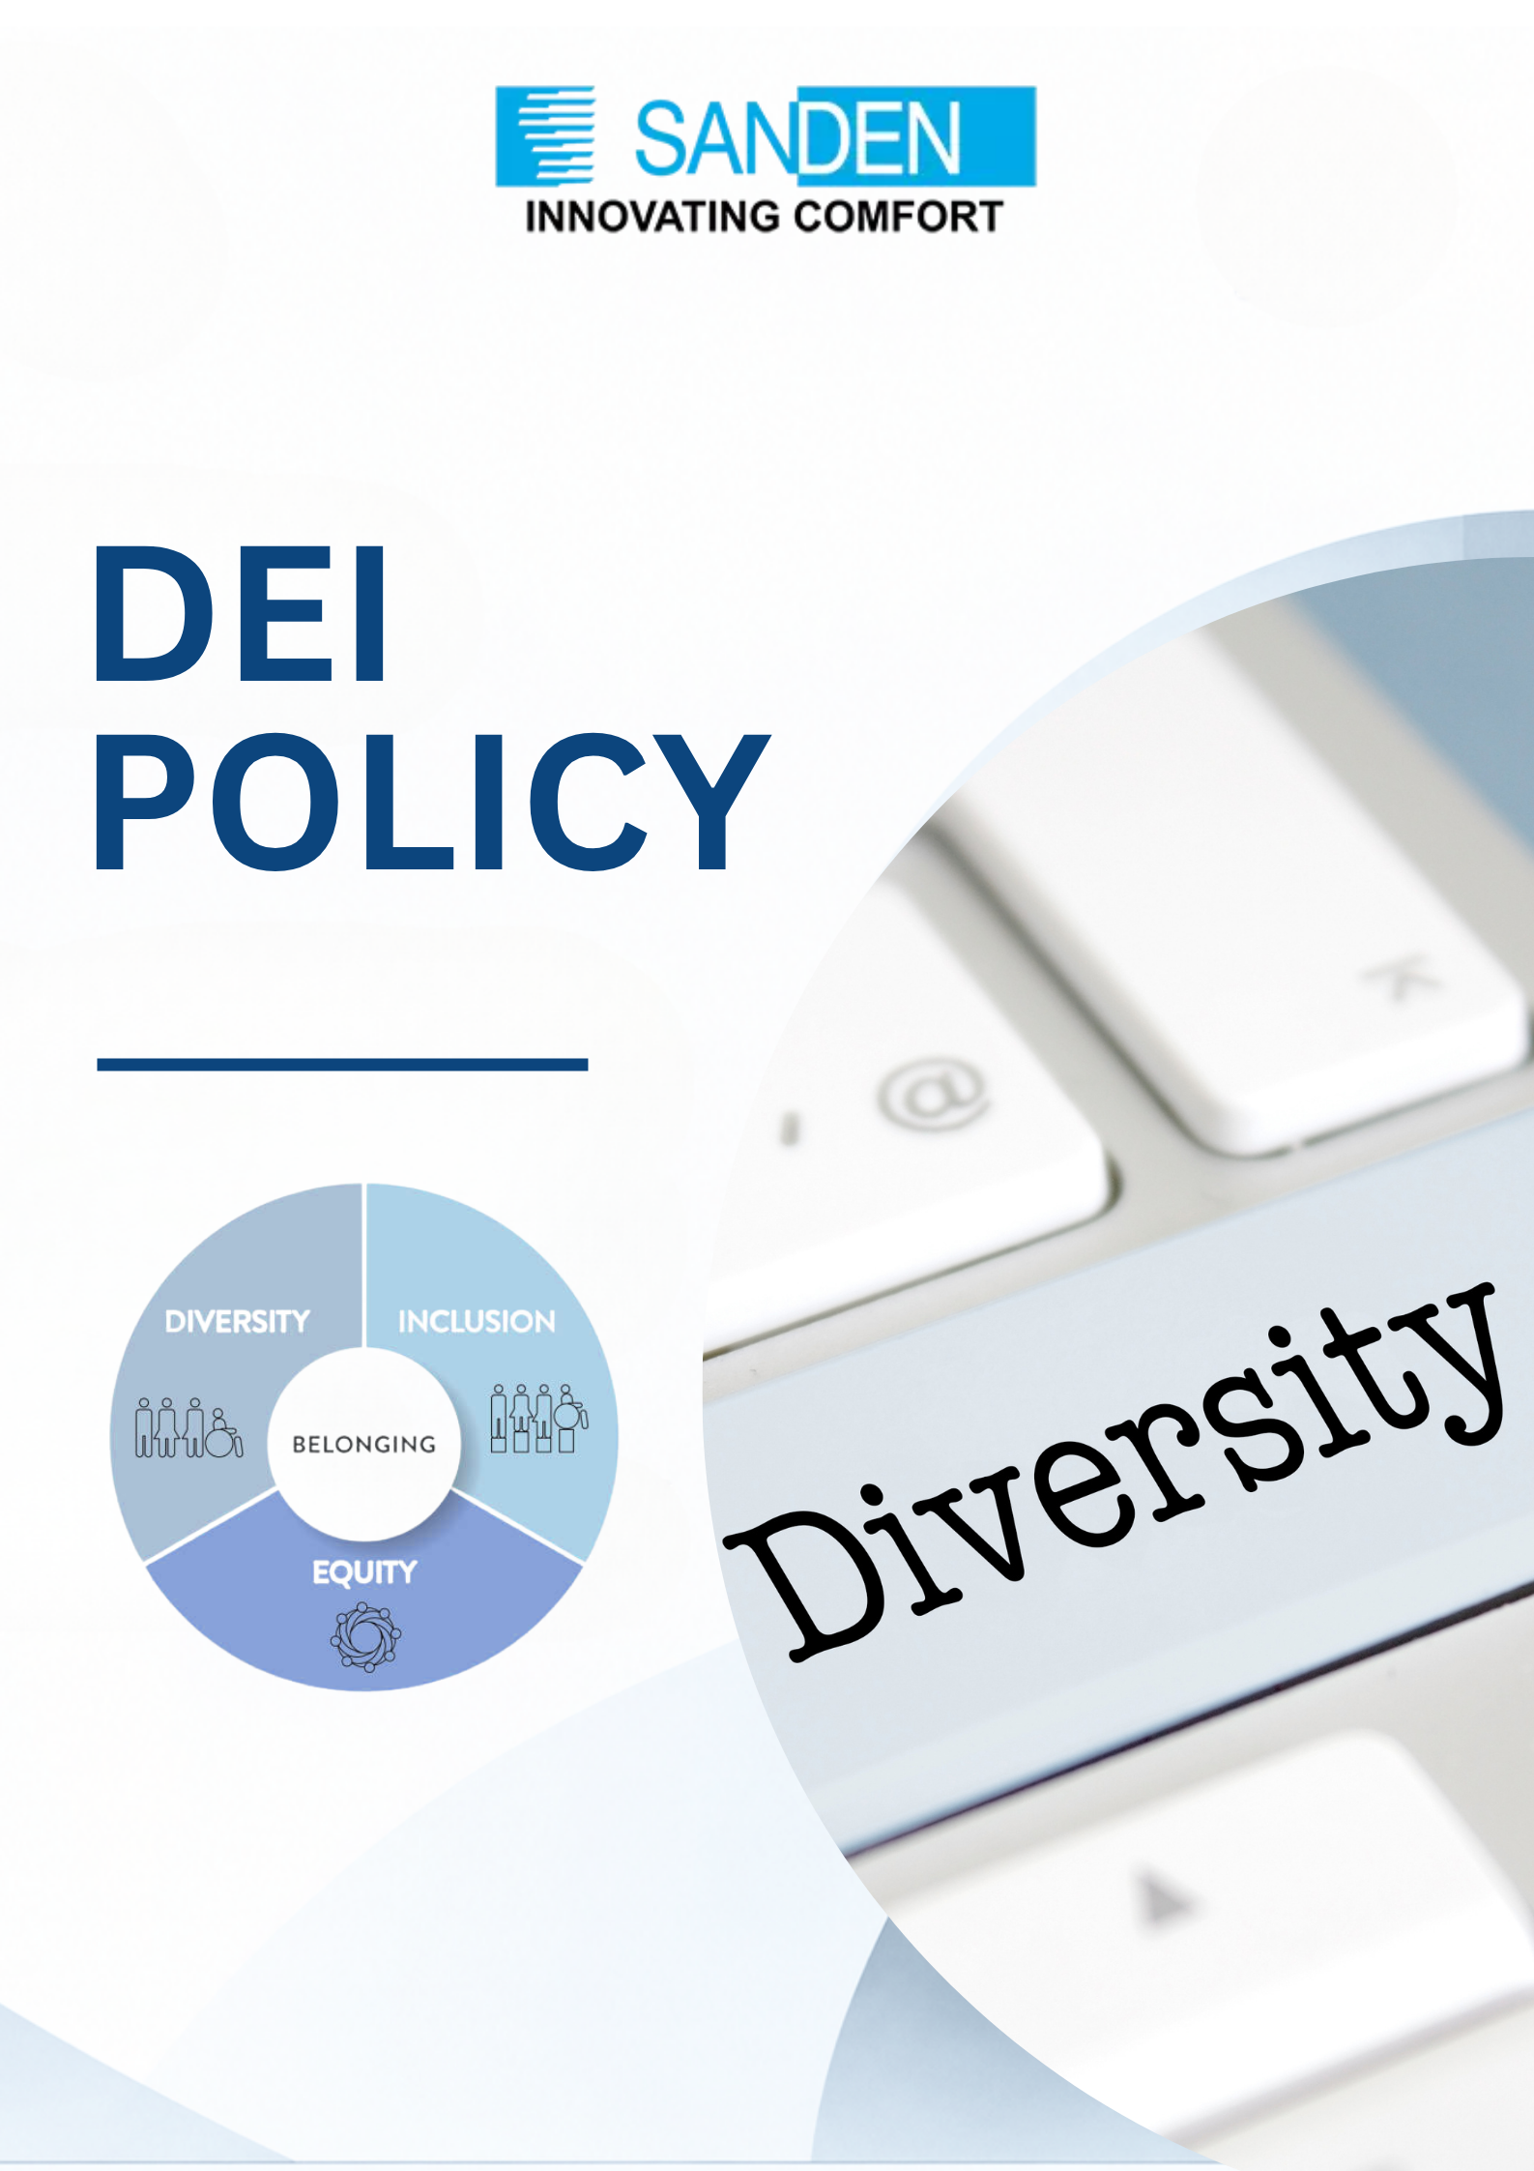

TABLE OF CONTENTS

S. No. | Topic
1 | OBJECTIVE
2 | SCOPE
3 | DEFINITIONS
4 | COMMITMENT TO DEI & GUIDING PRINCIPLES
5 | ZERO TOLERANCE FOR DISCRIMINATION AND HARASSMENT
6 | EMPLOYEES RESPONSIBILITIES
7 | COMMUNICATION AND TRAINING
8 | REPORTING AND TRANSPARENCY
9 | REVIEW AND UPDATES
10 | MONITORING AND CONTINUOUS IMPROVEMENT

DIVERSITY EQUITY & INCLUSION POLICY

1. OBJECTIVE
Sanden Vikas (India) Private Limited is committed to fostering a diverse, equitable, and inclusive workplace where all employees feel valued, respected, and empowered.
This policy outlines our commitment to diversity, equity, and inclusion in all aspects of our operations, ensuring a work environment that promotes fairness and equal opportunity for all.

This policy establishes our core principles, scope, guidelines, and action plan for achieving an inclusive environment.

2. SCOPE
This policy applies to all subsidiaries/ group companies of Sanden Vikas. It covers all aspects of employment, including recruitment, training, professional developments, compensation, and workplace conduct.
The policy applies to all employees, regardless of their role, level, department, or location.

3. DEFINITIONS
Diversity: Refers to differences in social, racial, cultural, socioeconomic backgrounds, geographical locations, age, interests, physical & mental abilities, etc., that make an individual unique.
Equity: Refers to the process of ensuring that practices and programs are fair, impartial, and provide equal outcomes for every individual. It aims to ensure equal treatment, access, opportunity, and advancement for people
Inclusion: Refers to conscious efforts, behaviors, policies, and norms to make every person feel seen, heard, and valued for their unique differences. Usually achieved when all members of an organization feel psychologically safe and included.

4. COMMITMENT TO DEI & GUIDING PRINCIPLES
Sanden Vikas values diversity in all forms, including but not limited to race, ethnicity, gender, age, religion, disability, sexual orientation, socioeconomic background, and cultural perspectives. We actively seek to create a workforce that reflects the diverse communities we serve. We aspire to have 25 % diverse work force by 2030.

4.1 RECRUITMENT AND HIRING:
- Conduct targeted recruitment drives in women's engineering colleges and organizations
- Ensure equal representation in leadership positions and training programs.
- Partner with diverse communities and organizations for recruitment.
- Partner with organizations supporting people with disabilities for recruitment.
- Track demographics across all levels and identify areas for improvement using Workforce data analysis.

- Present special referral schemes for hiring women employees and individuals with 2 disabilities, with the referral bonus being 10% - 15% higher than usual.

4.2 WORK ENVIRONMENT:
- Create an inclusive communication environment with gender-neutral language and imagery.
- Adhere to accessibility standards in both physical and digital spaces to ensure a workplace that is accessible to all employees.
- Provide maternity & childcare support.
- Foster an environment of respect and acceptance for all.
- Train managers/supervisors on supporting employees with disabilities.
- Provide an Employee Resource Group for employees with disabilities or a platform for support and advocacy for employees with disabilities.

4.3 LEARNING & DEVELOPMENT:
- Provide mentorship and sponsorship programs for female employees.
- Provide ongoing DE&I training programs for all employees, focusing on fostering understanding, recognizing unconscious biases, and actively contributing to an inclusive workplace culture.

4.4 EQUAL AND FAIR COMPENSATION
We provide equal compensation for all employees without any biasness, and our role grading and remuneration review processes actively consider equity in both grading and remuneration, and we will continue to develop strategies and initiatives to resolve any Identified gaps.

4.5 EQUITY AND FAIR TREATMENT
We provide fair opportunities to all employees and ensure that workplace policies and practices do not create barriers to success. We strive to eliminate bias and discrimination in decision-making processes and to foster a culture of meritocracy and fairness.

5. ZERO TOLERANCE FOR DISCRIMINATION AND HARASSMENT
Sanden Vikas strictly prohibits discrimination, harassment, or retaliation of any kind. Any reported instances will be promptly investigated, and appropriate action will be taken against those found in violation of this policy.

6. EMPLOYEES RESPONSIBILITIES
- DEI is everyone’s responsibility requiring purposeful actions every day. Every employee is trained on DEI and is responsible for:
- Respecting the dignity and diversity of all people.
- Creating an inclusive environment that is free from discrimination, harassment and bullying.
- Enhancing their awareness of potential unconscious bias and how that might hinder our ability to be more inclusive and collaborative with one another.
- Focusing on conscious inclusion to be more intentional with their actions to drive diversity, equity and belonging.

7. PEOPLE LEADERS’ RESPONSIBILITIES
People leaders are accountable for specific DEI responsibilities and for achieving DEI outcomes as part of their job performance. These responsibilities include but are not limited to:
- Ensuring that employment-related decisions are free from discrimination.
- Setting individual DEI goals to foster diverse representation and an inclusive environment within their teams.
- Engaging in conscious inclusion and other behaviors that promote equality.
- Committing to an individual goal as part of annual goals- and objectives-setting to help meet our DEI responsibilities.
- Mitigating potential unconscious bias in employment decisions and talent practices (including performance and development, compensation, and hiring).
- Creating an inclusive and safe work environment that supports DEI and behaviors that reinforce our core values.
This includes:
  - Ensuring a work environment that is free from discrimination, harassment and bullying.
  - Consistently displaying inclusive leadership behaviors, valuing all perspectives, and listening to diverse points of view.
  - Encouraging employees to collaborate, make suggestions, and respect and listen to diverse opinions.
- Cultivating a culture that inspires respect for all employees, customers, vendors, contractors, and others in the work environment.
- Appropriately addressing any other behavior not consistent with this or other policies, or with applicable laws relating to equal opportunity, diversity, equity, or inclusion
8. CONFIDENTIALITY
This document is not for general distribution and is meant for use only by the person/persons they are specifically issued to. This document shall not be loaned or given to anyone outside Sanden Vikas and its subsidiary companies. Copying or unauthorized distribution of this document, in any form or means including electronic, mechanical, photocopying or otherwise is illegal.

9. MONITORING AND REVIEW
- This policy will be reviewed once in two years or as required by the Corporate HR department in consultation with senior management and empowered women board.
- Amendments may be made to ensure alignment with company objectives, government regulations, and industry best practices.
- All employees and stakeholders are expected to understand and uphold the principles outlined in the policy.
- Employees who experience or witness discrimination, harassment, or exclusionary behaviour are encouraged to report their concerns without fear of retaliation
- The document is the property of Sanden Vikas, and it is intended for limited circulation as per management discretion.
- Management reserves the right to change or update the policy without prior notice.

10. CONCLUSION
At Sanden Vikas, we believe that diversity, equity, and inclusion are essential to our success. We are committed to creating an environment where every individual can thrive and contribute to our shared vision. This policy reflects our dedication to a more inclusive and equitable workplace for all.

