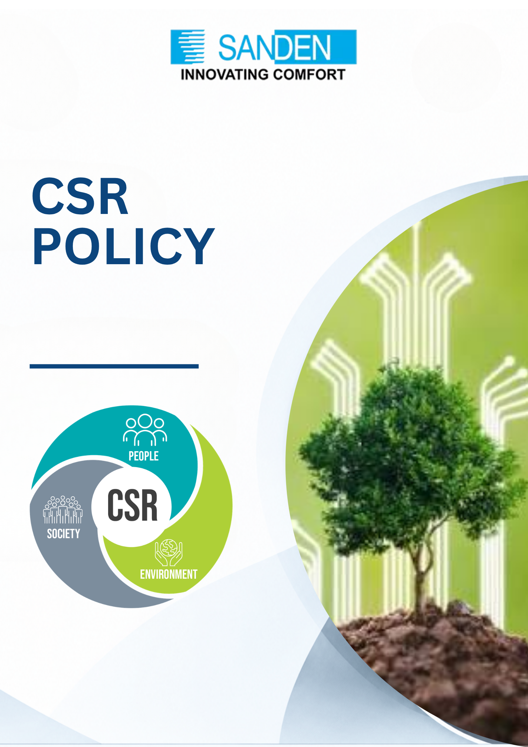

TABLE OF CONTENTS

S. No. | Topic
1 | PREAMBLE
2 | VISION
3 | MISSION
4 | CSR PHILOSOPHY
5 | FOCUS AREAS OF CSR
6 | MODES OF IMPLEMENTATION
7 | CSR GOVERNANCE STRUCTURE
8 | CSR BUDGET & EXPENDITURE
9 | MONITORING & REPORTING
10 | IMPACT ASSESSMENT
11 | AMENDMENT

csr policy

1. PREAMBLE
Sanden Vikas (India) Private Limited is committed to conducting business in a socially responsible and sustainable manner. As part of its commitment to inclusive growth and environmental stewardship, the Group undertakes Corporate Social Responsibility (CSR) initiatives that contribute positively to society while aligning with national development priorities and stakeholder expectations.
This CSR Policy has been formulated in accordance with Section 135 of the Companies Act, 2013, read with the Companies (Corporate Social Responsibility Policy) Rules, 2014, as amended from time to time.

2. VISION
To contribute meaningfully to social and environmental well-being by empowering communities through education and skills, and by conserving natural resources for future generations.

3. MISSION
- To enable access to quality education and employable skills for underprivileged and vulnerable sections of society
- To promote environmental conservation and climate responsibility through measurable and impactful initiatives
- To Promote gender equality and women empowerment through inclusive education, skill development, employability enhancement, leadership-building initiatives and healthcare awareness and prevention
- To deliver CSR programmes through direct implementation and trusted institutional partnerships, ensuring transparency and effectiveness

4. CSR PHILOSOPHY
Sanden Vikas’s CSR philosophy is based on:
- Inclusivity – addressing social and environmental challenges across communities
- Impact orientation – focusing on long-term, measurable outcomes
- Partnership-driven approach – collaborating with credible institutions and NGOs
- Alignment with business values – integrating CSR with the Group’s ESG and sustainability journey

5. FOCUS AREAS OF CSR

5.1 Education & Skill Development
Initiatives aimed at enhancing educational access, quality, and employability, especially for youth, women, and marginalized communities.

Indicative Activities:
- Support for primary, secondary, and higher education, including infrastructure,
digital learning tools, and scholarships

- Skill development and vocational training programs aligned with industry needs
- Employability enhancement through technical training, apprenticeships, and life-skills development
- Support to educational institutions, ITIs, and training centres
- Teacher training and capacity-building initiatives

5.2 Healthcare, Gender Equality & Women Empowerment
- Preventive and primary healthcare initiatives for communities
- Health camps, nutrition support, and access to basic medical facilities
- Women empowerment through education, skill development, employability, and leadership initiatives
- Support for women-led self-help groups and livelihood programs

5.3 Environmental Conservation
Initiatives aimed at protecting the environment, conserving natural resources, and promoting climate resilience.

Indicative Activities:
- Tree plantation and afforestation programs
- Water conservation initiatives including rainwater harvesting and watershed development
- Waste management, recycling, and plastic reduction initiatives
- Biodiversity conservation and habitat restoration
- Awareness programs on environmental sustainability and climate change
(Aligned with Schedule VII (iv) of the Companies Act, 2013)

6. MODES OF IMPLEMENTATION
CSR activities may be undertaken through the following modes:

6.1 Direct Implementation
CSR projects executed directly by Sanden Vikas through its internal teams, plants, or designated CSR personnel.

6.2 Implementation through Trust
CSR activities may also be implemented through Shri A. K. Aggarwal Charitable Trust, a registered trust engaged in social and environmental development activities, subject to compliance with applicable CSR rules.
The Trust shall:
- Undertake activities aligned with the approved CSR focus areas
- Maintain proper utilization records and impact documentation
- Submit periodic progress and utilization reports to the Company

7. CSR GOVERNANCE STRUCTURE

7.1 CSR Committee
CSR committee shall comprise of two Directors of the Company who will be nominated by the Board of Directors as and when required.

At present, following is the composition of CSR Committee:
1. Mr. Praveen Agarwal, Managing Director as Chairman
2. Mr. Naveen Agarwal, Executive Director as Member
3. Mrs. Puja Agarwal as Member

7.2 Board of Directors
The Board shall:
- Approve the CSR Policy and any amendments
- Ensure statutory compliance and disclosures
- Recommend CSR projects and expenditure
- Monitor implementation and impact of CSR initiatives

8. CSR BUDGET & EXPENDITURE
- The Company shall allocate CSR funds in accordance with Section 135 of the Companies Act, 2013 (minimum 2% of average net profits of the preceding three financial years, as applicable).
- CSR expenditure may include project costs, implementation costs, and impact assessment expenses as permitted under law.
- Surplus arising out of CSR activities shall not form part of business profits and shall be utilized as per CSR Rules.

9. MONITORING & REPORTING
- CSR Policy, activities and all CSR projects shall be monitored periodically against defined objectives and timelines.
- The CSR Committee shall review progress and impact at regular intervals.
- CSR disclosures shall be made in the Annual Report and on the Company website, as applicable.

10. IMPACT ASSESSMENT
Where applicable and as mandated under CSR Rules, independent impact assessments shall be conducted to evaluate the effectiveness and outcomes of CSR projects.

11. AMENDMENT
This Policy may be amended or modified by the Board of Directors of Sanden Vikas based on changes in regulatory requirements or organizational priorities.

