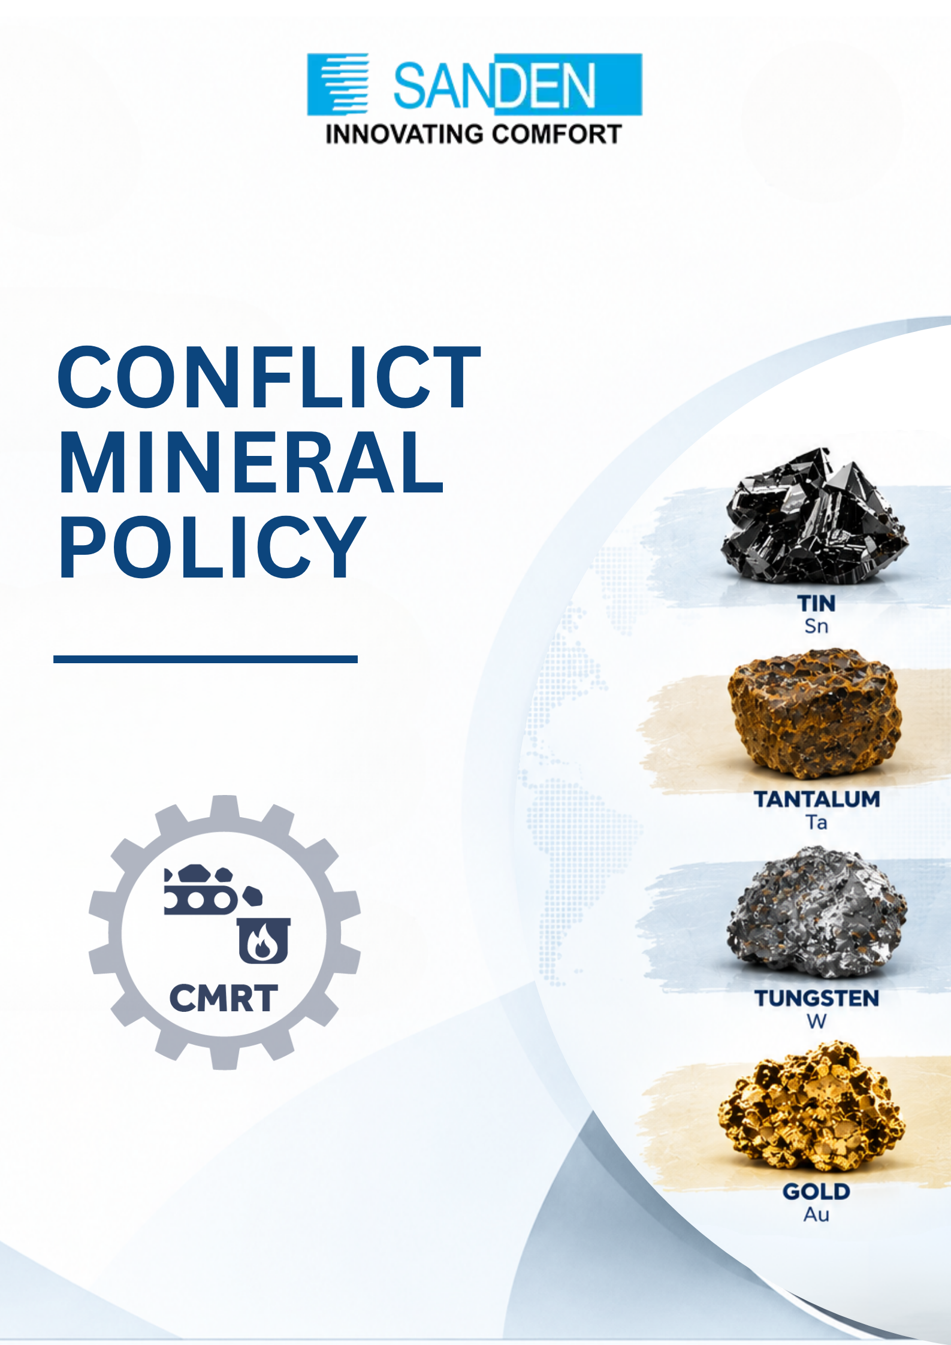

TABLE OF CONTENTS

S. No. | Topic
1 | PREFACE
2 | OBJECTIVES
3 | SCOPE AND APPLICABILITY
4 | RESPONSIBILITIES OF SUPPLIERS
5 | MONITORING
6 | AMENDMENTS
7 | PROCEDURE TO HANDLE CONFLICT MINERALS OR RESTRICTED SUBSTANCES

CONFLICT MINERALS & rESTRICTED SUBSTANCES policy

PREFACE:
It is observed that some of the valuable natural resources such as tin, tungsten, tantalum, and gold (3TG) are extracted from the Democratic Republic of Congo (DRC) or its surrounding countries by appalling activities like massacre and abduction of civilians by armed forces, looting, and enrolling of child soldiers. Procuring such minerals from these distressed regions is equivalent to funding for these inhumane activities.
The term “conflict minerals” is defined as minerals containing columbite-tantalite, also known as coltan (from which tantalum is derived); cassiterite (tin); gold; wolframite (tungsten); or their derivatives from DRC and the adjoining countries viz. Angola, Burundi, Central African Republic, Republic of the Congo, Rwanda, South Sudan, Tanzania, Uganda, Zambia. Also, other material originating from Conflict Affected & High-Risk areas as defined by OECD (Organization for Economic Co-operation and Development) Guidance.

REACH (Registration, Evaluation, Authorization and Restriction of Chemicals)
REACH regulation is adopted to improve the protection of human health and the environment from the risks that can be posed by chemicals. It also promotes alternative methods for the hazard assessment of substances to reduce the number of tests on animals.

RoHS
The RoHS Directive currently restricts the use of ten substances: lead, cadmium, mercury, hexavalent chromium, polybrominated biphenyls (PBB) and polybrominated diphenyl ethers (PBDE), bis(2-ethylhexyl) phthalate (DEHP), butyl benzyl phthalate (BBP), dibutyl phthalate (DBP) and diisobutyl phthalate (DIBP). These substances cause harm to environment upon end-of-life disposal of the product in which they are used.
The purpose of this Policy is to avoid the procurement of such Conflict Minerals and Restricted Substances. Sanden Vikas owns responsibility of materials with full deliberation and takes care to avoid the procurement or usage of such Conflict Minerals and Restricted Substances in our products.

OBJECTIVES
- To ensure not to source or use any Conflict Minerals (3TG) from DRC or its surrounding countries
- To Identify substances regulated under local, national, and international laws (e.g., REACH, RoHS, OSHA, EPA); and to ensure that minerals used in our products are from responsible sources.
- To deploy responsible procurement practices in our entire supply chain

SCOPE AND APPLICABILITY
- The Policy applies to all our businesses/units/subsidiaries or holding companies of the Sanden Vikas.
- This policy addresses the company's obligations to uphold national and internationally recognized human rights standards related to conflict minerals & restricted substances and extends to our value chain partners

RESPONSIBILITIES OF SUPPLIERS:
- Comply with the Conflict minerals reporting requirement & conduct due diligence of their own supply chain in alignment with internationally recognized framework such as OECD guidance.
- Report on the source of the conflict minerals used in their processes and or included in their products supplied to us.
- Ensure and review compliance with conflict mineral policy in line with Sanden Vikas ’s code of conduct.
- Declaration on the REACH/ RoHS.
The adherence of this policy is the responsibility of all relevant stakeholders. If any Supplier or Employee comes across a case of infringement of these guidelines, he/she should bring it to the notice of Business or Functional Heads in writing and the respective person shall take immediate and corrective measures.

MONITORING

The Head of Procurement/ SCM has primary day-to-day responsibility for implementing this Policy. Management at all levels are responsible for ensuring that those reporting to them are made aware of and understand the procedure and, if necessary and appropriate, are given adequate and regular training on it.

AMENDMENTS
The Company reserves its right to amend or modify this Policy in whole or in part, at any time without assigning any reason whatsoever. However, this Policy, in whole or in part, shall stand modified/amended from time to time, without any further action on the part of the Company, as and when there would be any statutory modification(s) / amendment(s) / revision(s) to the applicable provisions to it

PROCEDURE TO HANDLE CONFLICT MINERALS OR RESTRICTED SUBSTANCES:

Identify and Classify the Restricted Substance
  - Research applicable regulations: Familiarize with specific substance restrictions, including hazardous chemicals, heavy metals, or any other restricted materials.
  - Material Safety Data Sheets (MSDS): Review and maintain updated MSDS for each substance used in production or handling.
  - Labeling: Ensure substances are properly labeled according to legal requirements.
  - Classify substances: Identify if the substance falls under restricted or banned categories.

Conduct Risk Assessment
- Evaluate exposure: Analyze the possibility of exposure to employees, the environment, and end consumers.
- Health and environmental impact: Consider toxicity, potential for contamination, or long-term ecological damage.
- Control Measures: Define controls to mitigate risks such as ventilation systems, containment areas, or personal protective equipment (PPE).

Develop and Implement Substitution or Minimization Strategies
  - Research alternatives: Identify and test safer substitutes to replace restricted substances where feasible.

  - Minimize usage: Reduce the amount of restricted substance used in the manufacturing process without compromising product quality.
  - Supplier collaboration: Work with suppliers to source materials that comply with regulatory standards.

Compliance Documentation and Record Keeping
  - Tracking: Keep an inventory of restricted substances used in the production process.
  - Compliance certifications: Ensure that all materials purchased from suppliers have relevant compliance certificates (e.g., RoHS compliance, REACH registration).
  - Audit trail: Regularly audit processes to ensure compliance with applicable regulations.

Training and Awareness
  - Training programs: Provide training on the identification, handling, storage, and disposal of restricted substances.
  - Safety protocols: Implement clear guidelines for the management of restricted materials, including emergency response plans in case of spills or exposure.
  - Regular updates: Keep employees informed about changes in regulatory requirements through ongoing education and awareness programs.

Monitor and Review Compliance
  - Internal audits: Conduct regular audits to ensure all procedures are being followed and compliance is maintained.
  - Review regulatory changes: Stay updated on changing regulations related to restricted substances (e.g., updates to REACH or RoHS) and adjust internal procedures accordingly.
  - Corrective actions: Implement corrective actions immediately if any non-compliance or deviations from established procedures are found.

Safe Disposal and Waste Management
  - Waste segregation: Segregate hazardous waste from other types of waste for safe disposal.
  - Disposal methods: Follow approved disposal methods (e.g., incineration, recycling, or specialized disposal services) as per regulatory requirements.
  - Record keeping: Maintain detailed records of waste disposal, including quantities and methods used.

Reporting and Communication
  - Regulatory reporting: Submit necessary reports and documentation to regulatory authorities as required by law.
  - Customer communication: If the substance affects products sold to customers, inform them about the regulatory status and any necessary actions they need to take.

