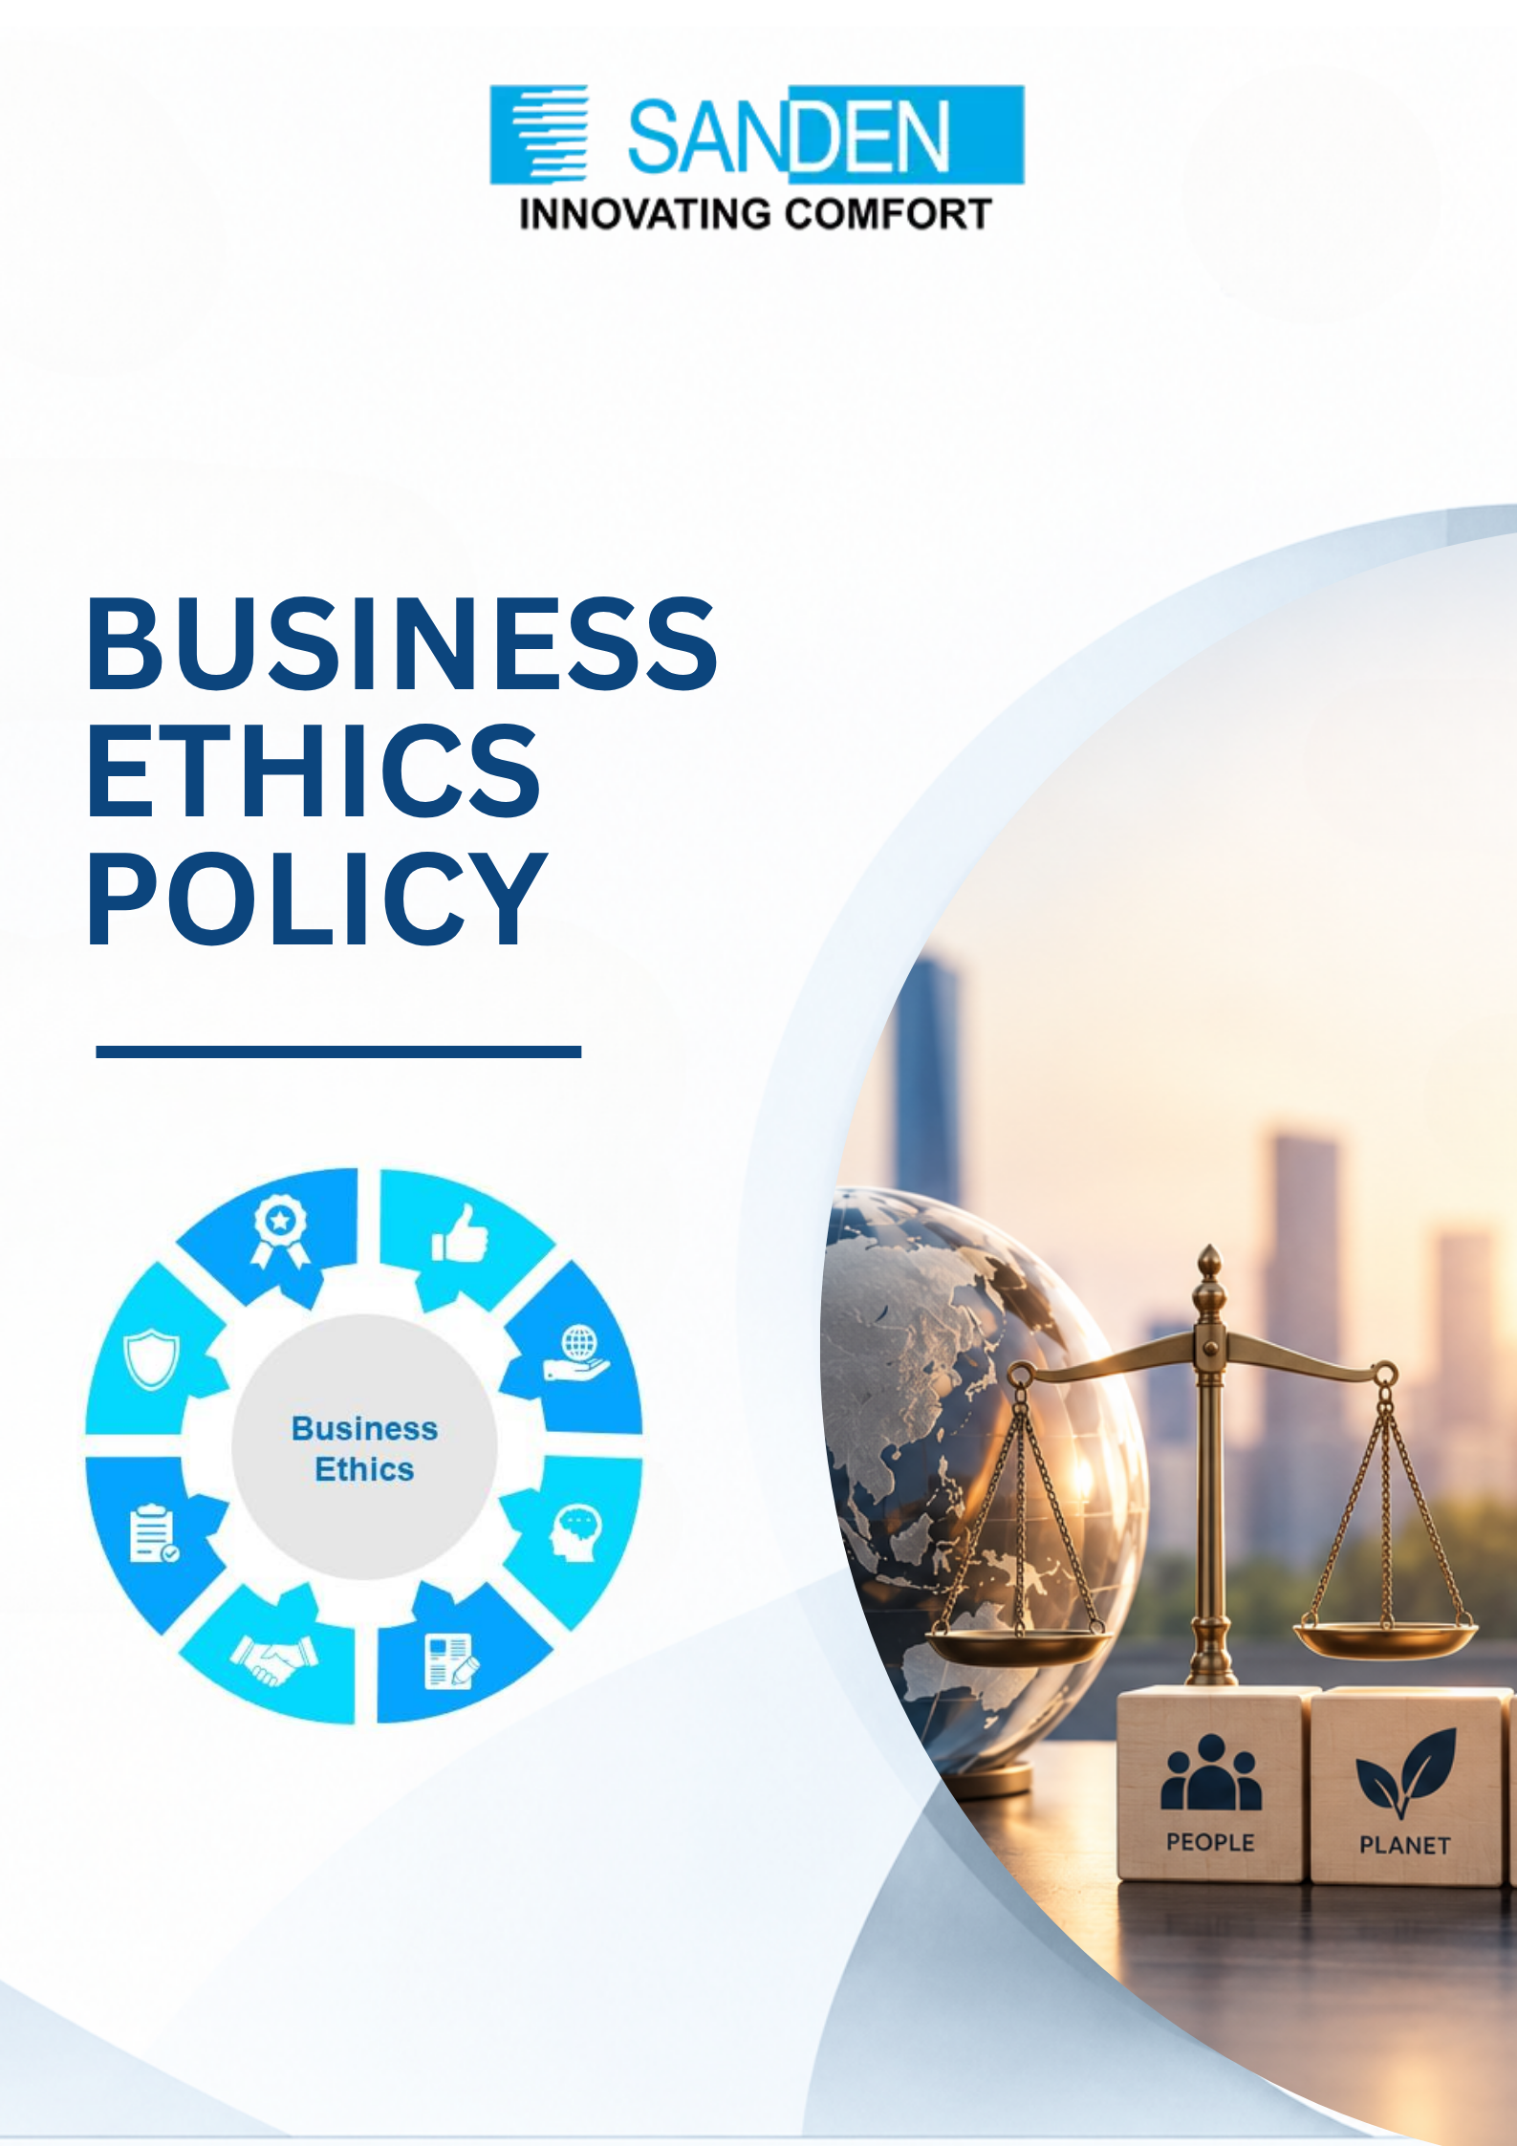

TABLE OF CONTENTS

S. No. | Topic
1 | PREFACE
2 | OBJECTIVE
3 | SCOPE
4 | KEY BUSINESS PRINCIPLES AND PRACTICES
5 | WORKPLACE ETHICS
6 | INTELLECTUAL PROPERTY RIGHT
7 | COMPLIANCE AND LEGAL FRAMEWORK
8 | REPORTING AND ACCOUNTABILITY
9 | REVIEW AND UPDATES
10 | MONITORING AND CONTINUOUS IMPROVEMENT

BUSINESS ETHICS policy

1. PREFACE
At Sanden Vikas (India) Private Limited, our commitment to ethical practices underpins all our business operations. We shall comply with the ethical practices defined through National Guidelines on Responsible Business Conduct (NGRBC) & other applicable laws. This Business Ethics Policy serves as a guide for employees, partners, and stakeholders to uphold the highest standards of integrity, transparency, and accountability in every aspect of our work.

CORE VALUES OF SANDEN VIKAS
Sanden Vikas has scripted a success story by following its Core Values of Truth, Honesty, Integrity; Respect and Discipline; Customer Delight; Collaboration, and Challenge and Innovation over the past four decades. These core values and business philosophy form part of our endeavors and constitute the foundation of our position as an industry leader.

2. OBJECTIVE
It is important that we act professionally, fairly and with utmost integrity in all our business dealings and relationships, wherever we operate or engage with competitors, suppliers, distributors or any other member of our supply chain.
Some of the key objectives of the policy are:
- Zero tolerance towards “unfair methods of competition” and “unfair or deceptive acts or practices”.
- Anti-competitive agreements (horizontal and vertical) included in cartelization.
- Abuse of dominant market position by a company.
- Combinations (mergers and acquisitions) that adversely affect competition.
- Fair business and governance policies.
- Establish a framework for ethical leadership and decision-making.
- Ensure compliance with applicable laws and regulations.
- Promote stakeholder trust through transparent and accountable practices.
- To promote and sustain competition in markets, protect consumer interests, and ensure freedom of trade for market participants.

3. SCOPE
- The Policy applies to all the employees in businesses/units/subsidiaries or holding companies of the Sanden Vikas.
- Sanden Vikas Business Ethics Policy (Policy) provides the general rules for our professional conduct, adhering to our values, core purpose & provide directives for compliance with applicable governmental laws, rules, and regulations.

4. KEY BUSINESS PRINCIPLES AND PRACTICES

4.1 INTEGRITY AND HONESTY
- We shall conduct business with honesty, fairness, and consistency.
- We shall ensure all communication, transactions, and decisions are truthful and transparent.

4.2 COMPLIANCE WITH LAWS AND REGULATIONS
- We are committed to full compliance with all applicable laws, regulations, and industry standards in every jurisdiction where we operate.

4.3 RESPECT FOR HUMAN RIGHTS
- We uphold and respect the principles of human rights as mentioned in detail in Human Rights Policy.

4.4 ENVIRONMENTAL RESPONSIBILITY
- Sustainability is an integral part of our operations. We actively seek to minimize our environmental impact through resource efficiency, waste reduction, conscientious consumption of water and the promotion of renewable energy solutions.

4.5 CONFIDENTIALITY AND DATA PROTECTION
- We shall protect confidential and proprietary information about the company, employees, clients, and other stakeholders.
- We shall comply with data privacy laws and safeguard personal and business data.

4.6 FAIR COMPETITION
- We shall compete fairly and ethically in all markets.
- We shall avoid practices such as price-fixing, bid-rigging, or other anti-competitive activities.
- We shall avoid abuse of dominant position by:
- Imposing unfair or discriminatory prices or conditions.
- Limiting or restricting the production, supply, or technical development of goods and services.
- We shall adhere to the norms of Antimonopoly Acts as per the region in which we operate to promote free competition by prohibiting monopolization and cartel formation with competitors to manipulate the market, having adverse impact on customers.
- Antimonopoly Acts of the country or region where illegal conduct concerns can apply regardless of the place of the conduct.
- Joining Associations
- We shall avoid the exchange of information related to price, quantity, capital investment, transaction status & transaction conditions with customers (including future prospect) with other members of the association.
- We shall not be a part of any activity having a negative impact on the economy, environment or human rights advocated by the association.

4.6 FRAUD & MONEY LAUNDERING
- Employees are expected to act professionally and uphold the company's values in handling financial matters including fraud, money laundering and misappropriation of funds.

4.7 FINANCIAL REPORTING
- We shall ensure the accounting, financial books and records are maintained accurately as per the prevailing norms and we shall present full, fair, and accurate results of operations and the financial conditions, false or misleading entries are strictly prohibited.

ANTI-BRIBERY AND CORRUPTION
- Employees and representatives are prohibited from engaging in bribery, corruption or any unethical practices to gain unfair advantages as mentioned in detail in “The Anti Bribery and Corruption Policy”.

4.9 RESPONSIBLE SOURCING
- We shall partner with suppliers and vendors who adhere to ethical standards.

- We shall regularly audit and evaluate supply chain practices on ethical business conduct.

4.10 COUNTERFEIT PARTS
- We shall be committed to supplying goods and services of the highest quality standards, backed by efficient after-sales service.
- We are committed to protecting our brand, intellectual property, and customers from fraudulent and substandard products.
- We shall take proactive measures to identify, report, and eliminate counterfeit products within the supply chain.
- Any company/ individual found to be engaged in counterfeiting activities shall face immediate legal action and termination of business relations.

4.11 EXPORT CONTROL AND ECONOMIC SANCTIONS:
- We shall ensure adherence to the import and export of our products as regulated and controlled by domestic and international laws & guidelines and comply with all customs regulations applicable in the country in which the company conducts business.
- We shall not conduct business with any sanctioned, embargoed, or otherwise prohibited party or participate in any unsanctioned boycott.

4.12 COMMUNITY ENGAGEMENT
- We shall actively support and invest in local communities.
- We shall promote economic and social development in regions where we operate.

5. WORKPLACE ETHICS

5.1 PROFESSIONAL CONDUCT
- We shall treat all colleagues, customers, and stakeholders with respect and courtesy.
- We shall promote a culture of collaboration, inclusion, and continuous learning.

5.2 CONFLICT OF INTEREST
- Employees must avoid situations where personal interests conflict, or appear to conflict, with the interests of Sanden Vikas.
- Any potential conflicts must be disclosed promptly to The Vigilance Officer.

5.3 ANTI-HARASSMENT
- We shall foster a workplace free from harassment, intimidation and bullying.
- We shall take immediate action to address any violations.

5.4 HEALTH AND SAFETY
- We shall maintain a safe and healthy working environment.
- We shall comply with occupational health and safety standards.

6. INTELLECTUAL PROPERTY RIGHT
- All intellectual property created by employees or other representatives in the course of their work for Sanden Vikas will be the sole property of the company unless otherwise agreed in writing.
- The employees of Sanden Vikas shall be properly recognized and rewarded for their contribution as per management discretion.
- We shall take proactive measures to protect our intellectual property, including trademarks, patents, copyrights, and trade secrets.

- Unauthorized use, reproduction, or distribution of Sanden Vikas’s intellectual property is strictly prohibited.

7. COMPLIANCE AND LEGAL FRAMEWORK

7.1 DOMESTIC LAWS AND GUIDELINESS (INDIA)
- Companies Act, 2013: Provisions on corporate governance, board composition, audit requirements, and CSR initiatives.
- Securities and Exchange Board of India (SEBI) Regulations: Guidelines for listed companies on corporate governance, disclosures, and investor protection.
- Indian Contract Act, 1872: Governs contracts and agreements within the company.
- Prevention of Corruption Act, 1988: Ensures ethical conduct in business dealings.
- Environment Protection Act, 1986: Encourages sustainable practices.
- The Competition Act, 2002: Aims to prevent anti-competitive practices.

7.2 INTERNATIONAL LAWS
- Japanese Antimonopoly Act, similar laws such as US Antitrust Laws, European Competition Law, Anti-Monopoly Law of China, etc. as per respective country norms.
- The above laws are indicative, laws as per the Policy principles/guidelines will also be complied.

8. REPORTING AND ACCOUNTABILITY

8.1 WHISTLE-BLOWING POLICY
- We encourage employees and stakeholders to report suspected misconduct, unethical behavior, or violations of this policy without fear of retaliation as per “The Vigil Policy”.

8.2 DISCIPLINARY ACTION
- Failure to adhere to this Business Ethics Policy may result in disciplinary action, up to and including termination of employment/business relationships.

9. REVIEW AND UPDATES
- This policy will be reviewed as required to ensure relevance and effectiveness. Updates will be communicated to all stakeholders promptly.
- In case of any doubt please contact the Departmental Head/ HR Head/Legal department for more clarity.

10. MONITORING AND CONTINUOUS IMPROVEMENT
- Training will be conducted to promote awareness and compliance with the policy.
- All employees and stakeholders are expected to understand and uphold the principles outlined in the policy.
- The document is the property of Sanden Vikas, and it is intended for limited circulation as per management discretion.
- Management reserves the right to change or update the policy without prior notice.

